

DXC RealTime Projects

AZ-900, DP - 203



**June 10, 2022**

**DXC TECHNOLOGY PVT.LTD.**

Name: Atharva Jadhav

Reg No: DXC262AB12035

**Project1 Name: Smart Vehicles**

Date: 10 June,2022

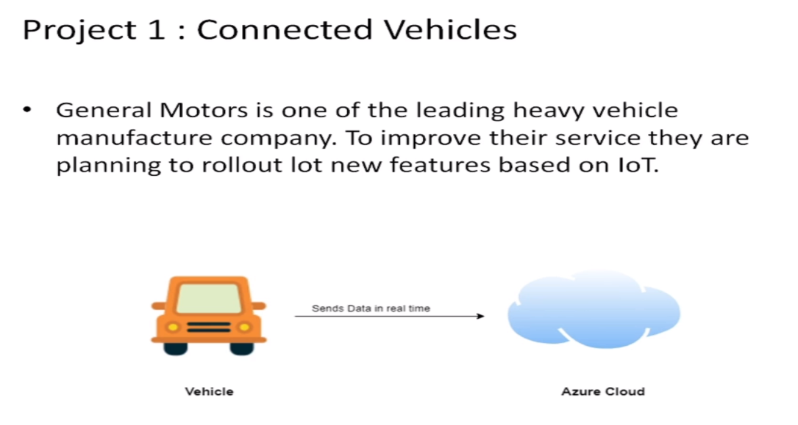

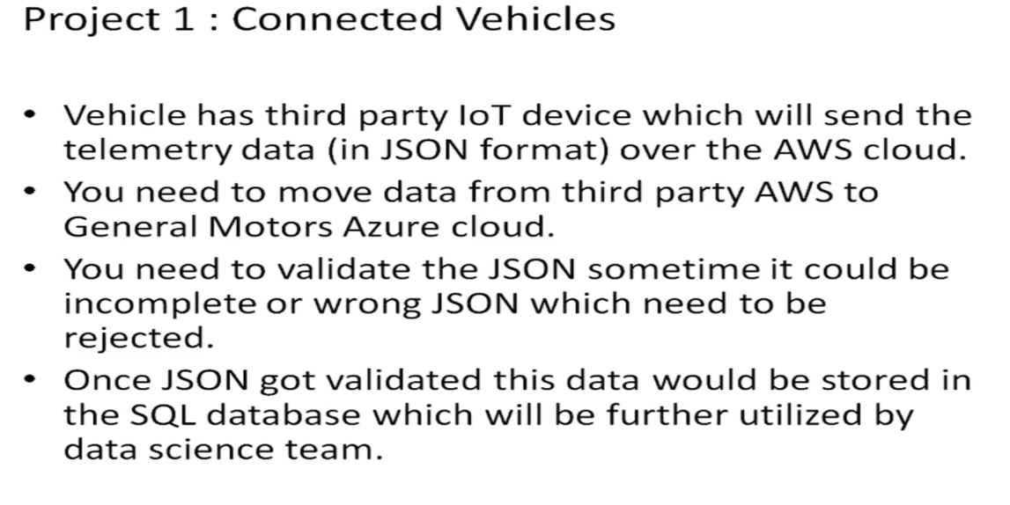

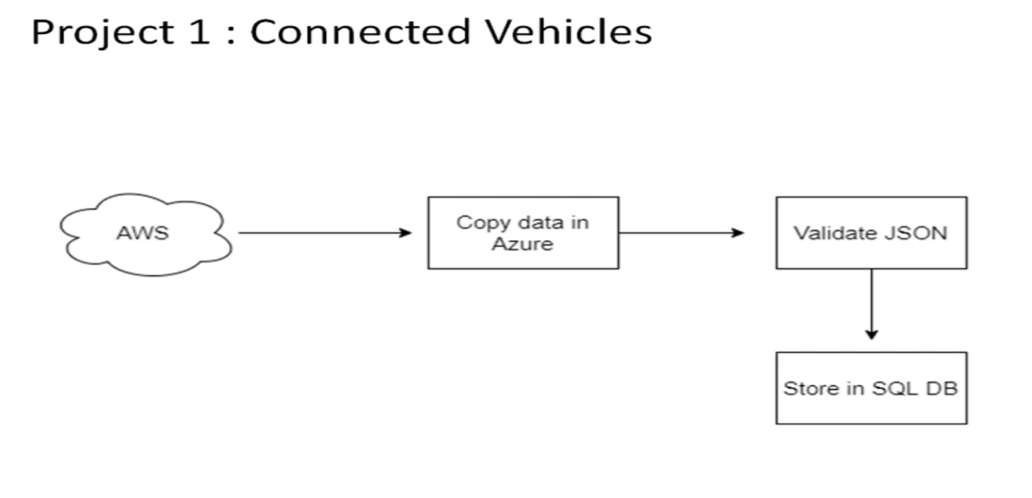

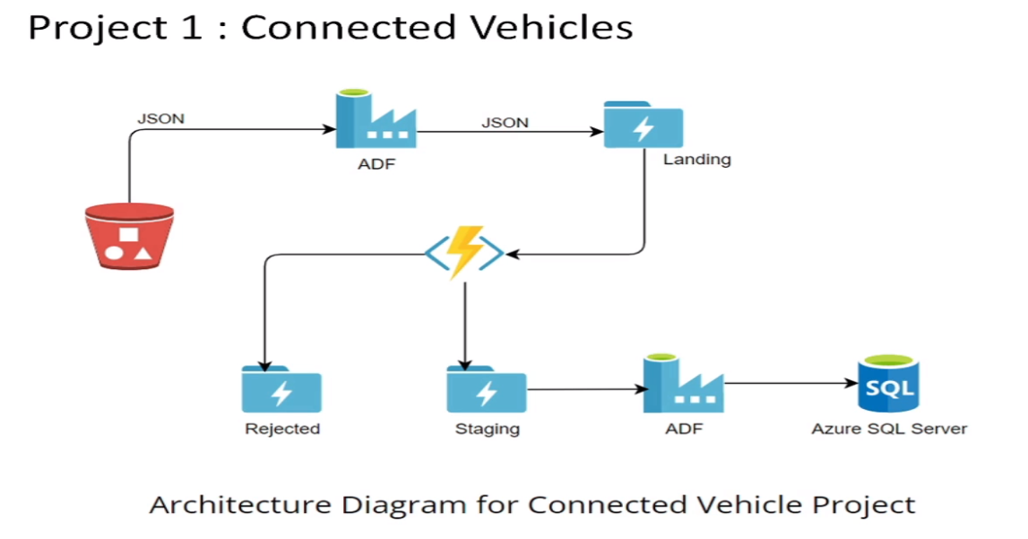

Practical Lab: Create **Azure Data Factory** Account For Data pipelines

Practical Lab: Create **ADF Pipeline** End to end pipeline with triggers enable

Practical Lab: Create **Azure blob trigger** logic

Practical Lab:Create Azure **SQL Server and Database**

Practical Lab: Add another pipelines for moving data from Staging to **SQL DB**

STEP-1

Open the Azure and search for Azure data Factory:

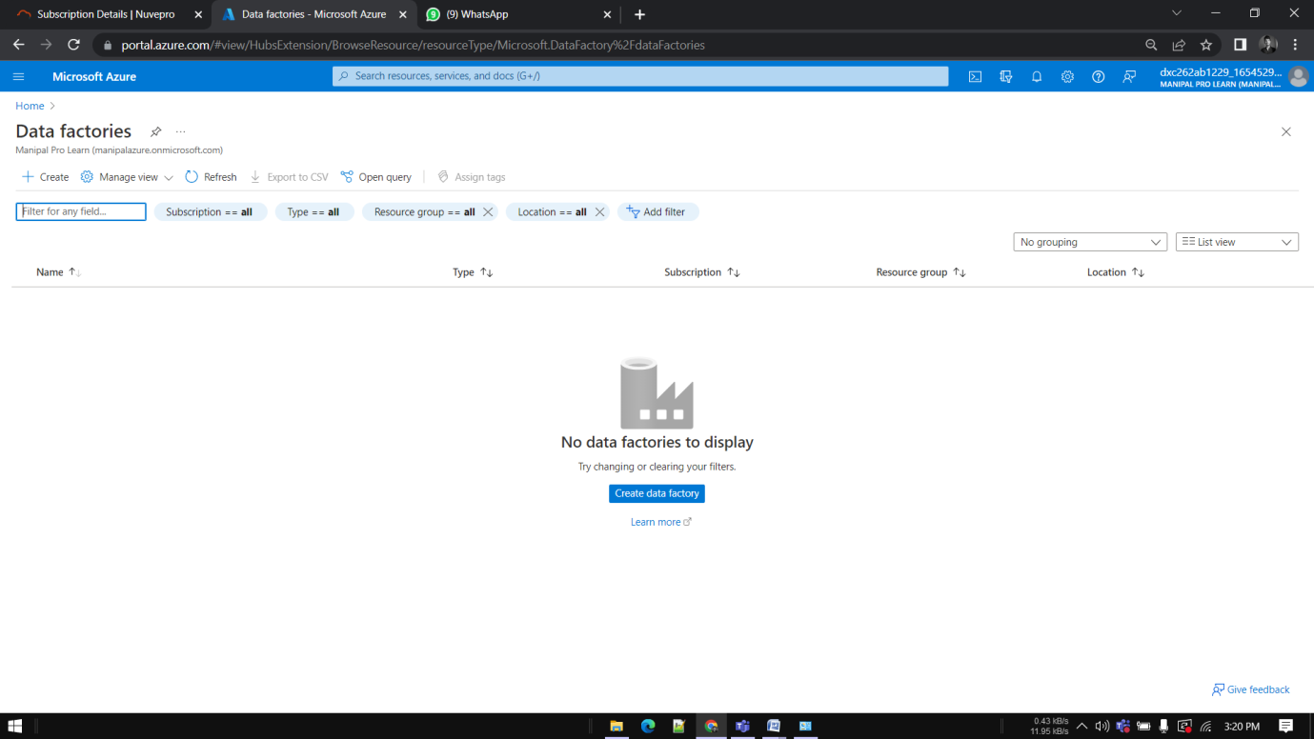

STEP-2

Open the Data Factory , Click on Create :

STEP 3

Enter the details

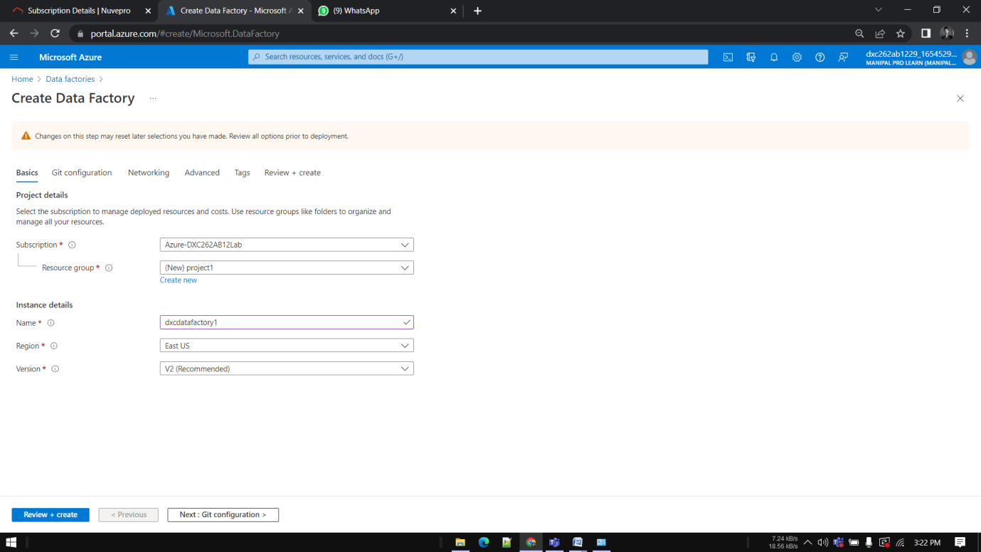

STEP 4

Click on Create when successfully validated.

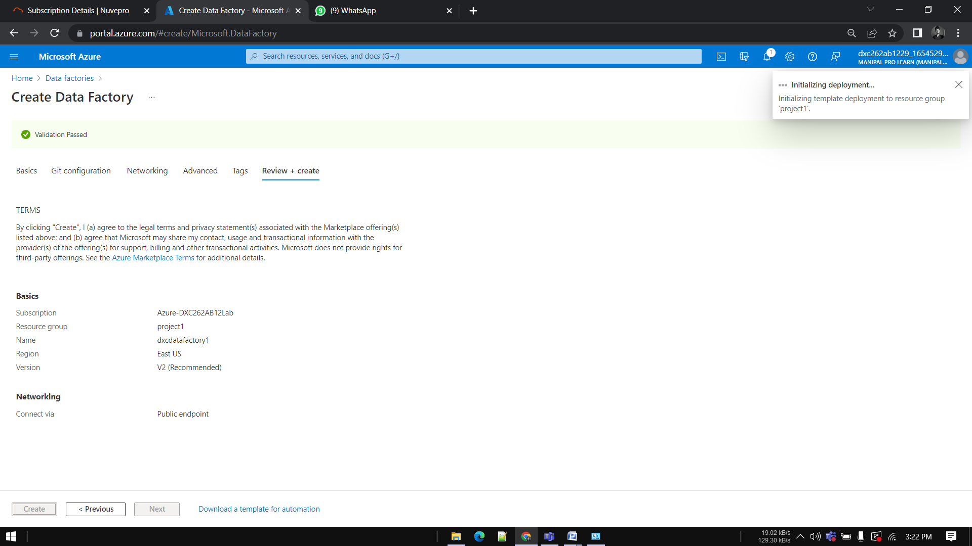

STEP 5

click on Go to Resource Group.

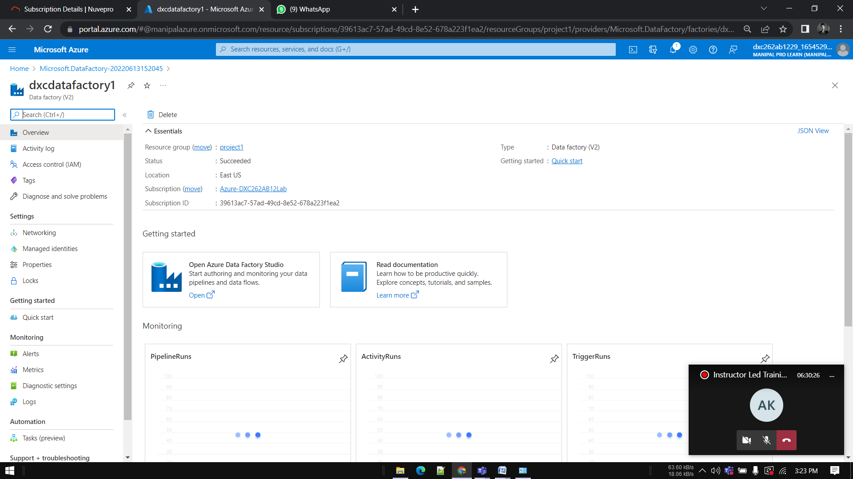

STEP 6

Click on open Azure Data Factory.

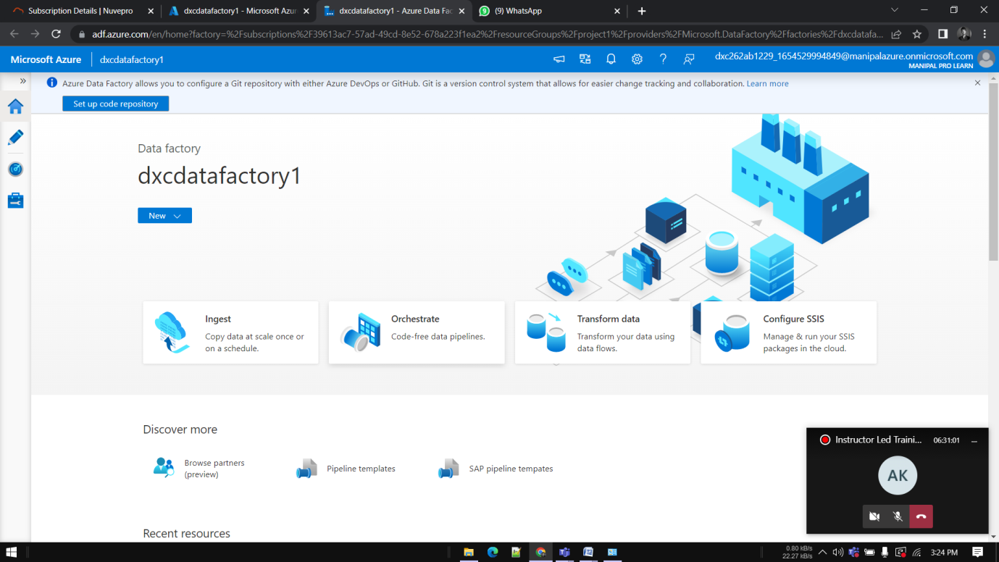

STEP 7

Go to Azure , search for storage. Click on Create.

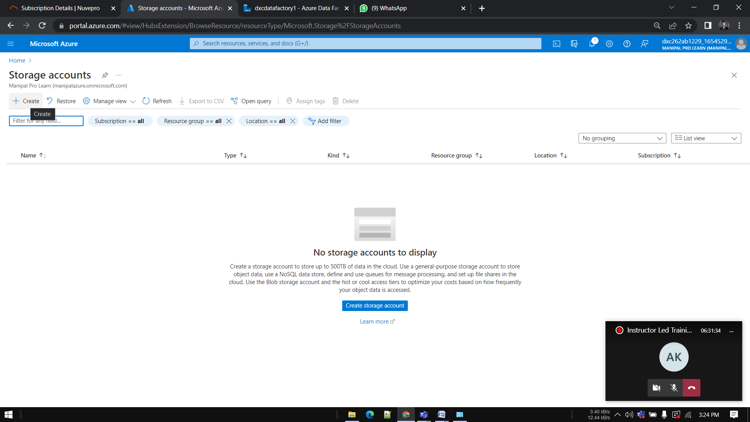

Enter data and click on Create.:

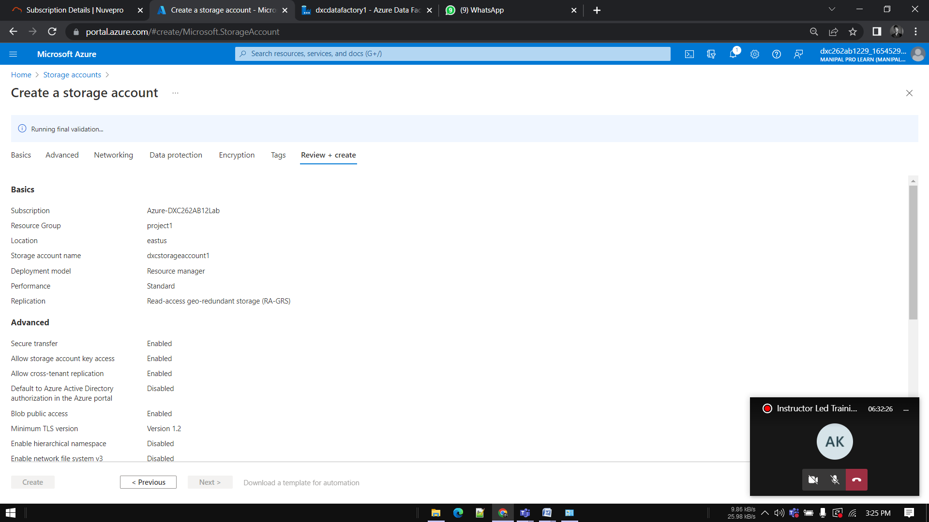

deployment is done 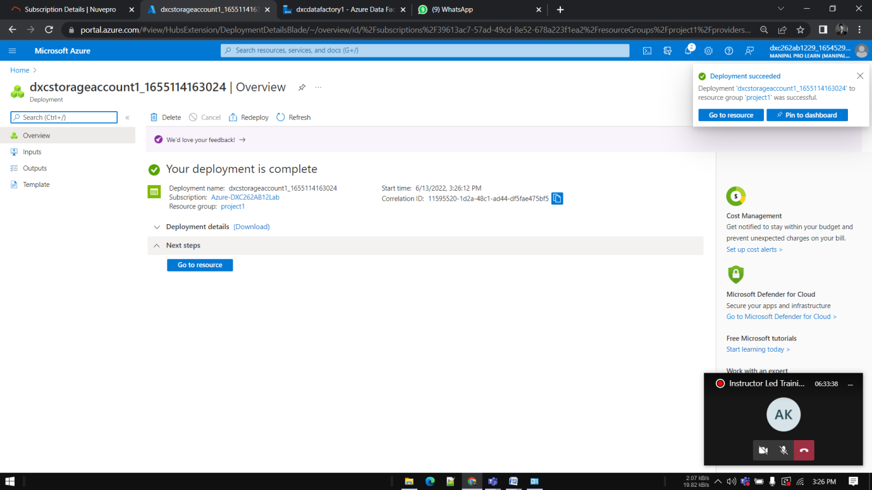

Go towards containers. Click on Create.

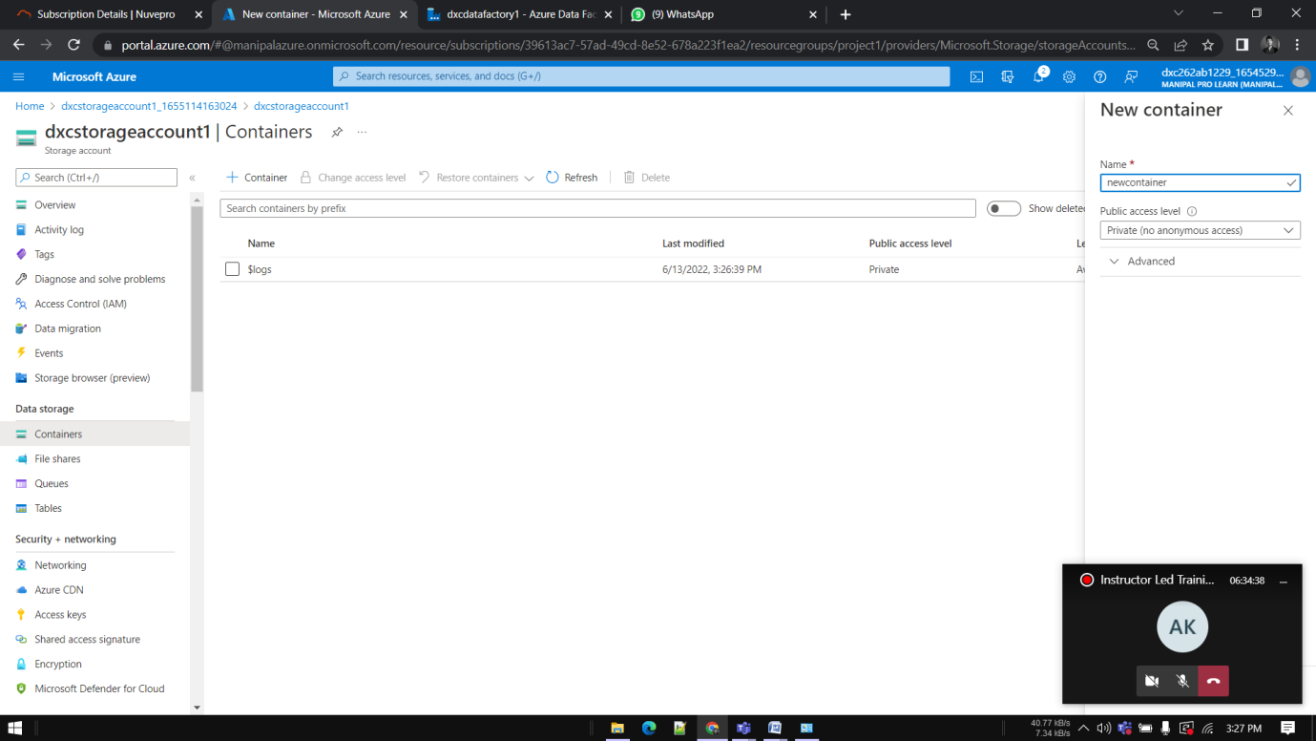

.

Give a name to the container Click on upload.

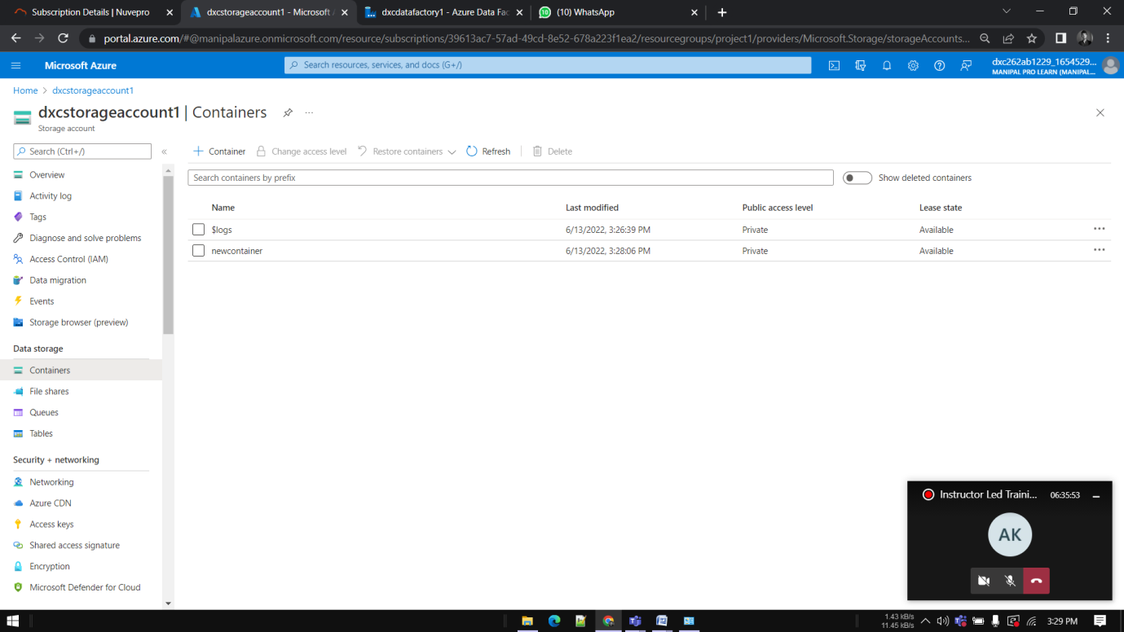

Add sample file to upload in blob.

Now we need a SQL database to send the data to . Go to **SQL DATABASES**.

Open it. Fill the necessary details and deploy it.

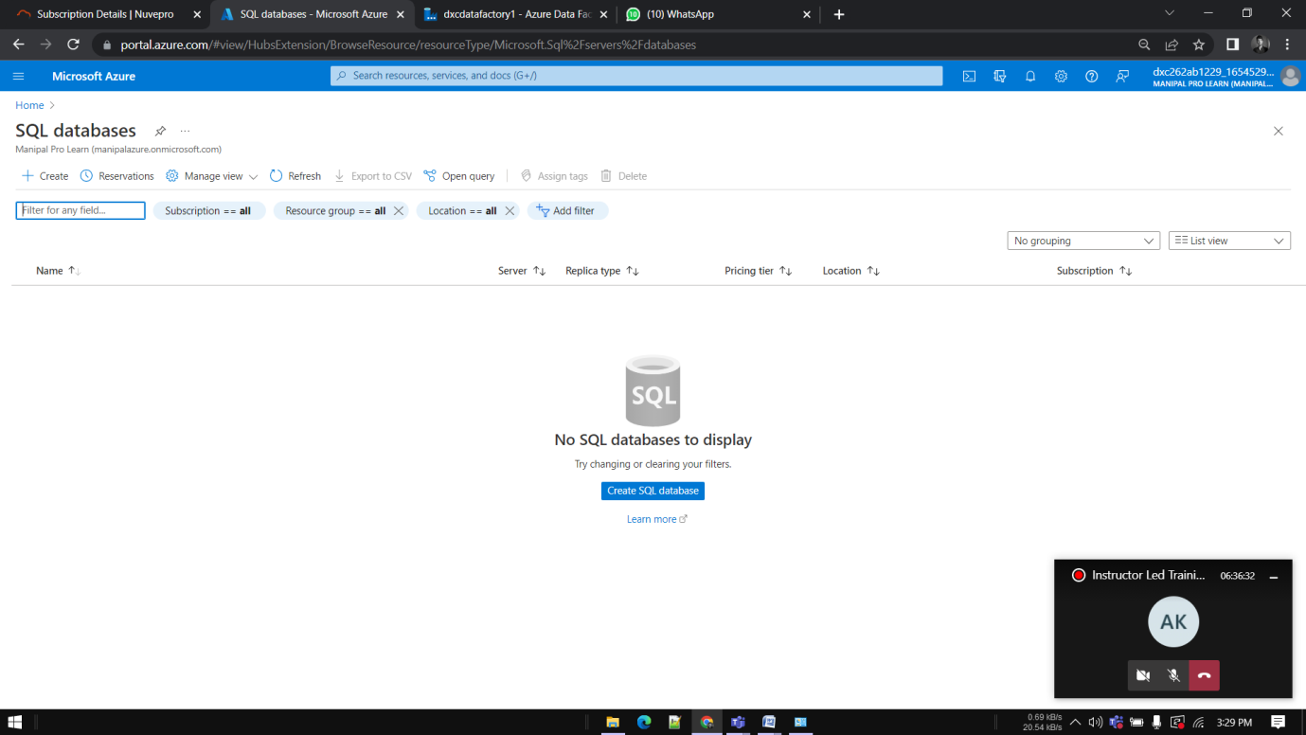

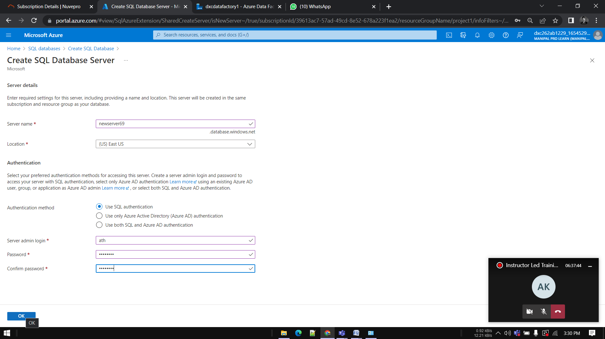

enable the firewall for the current IP and for the same azure cloud 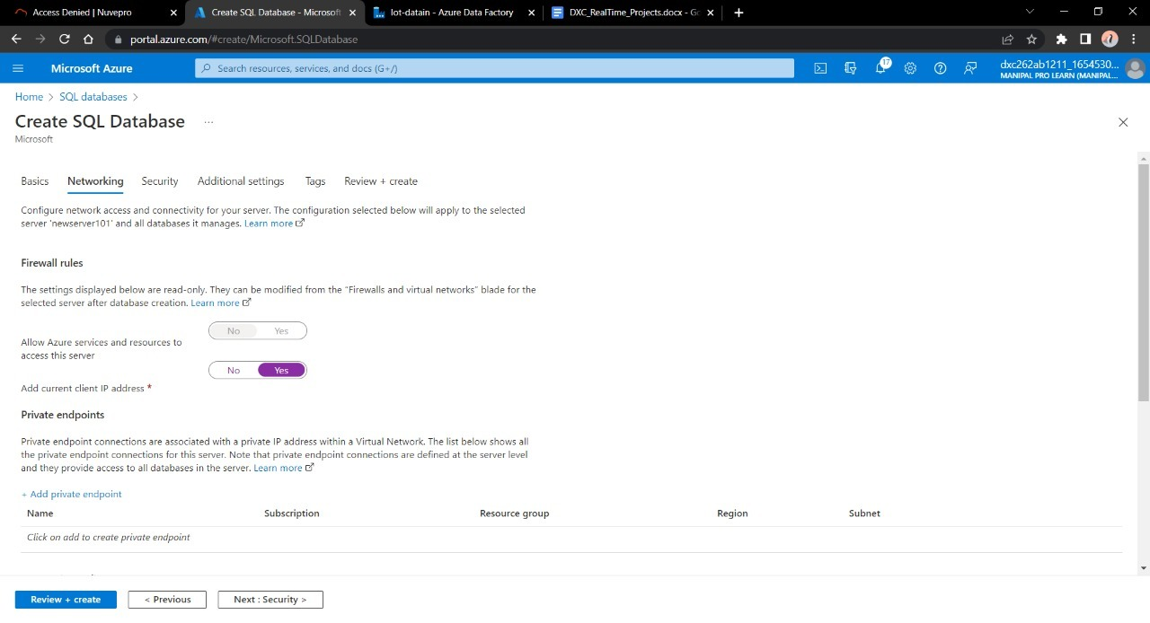

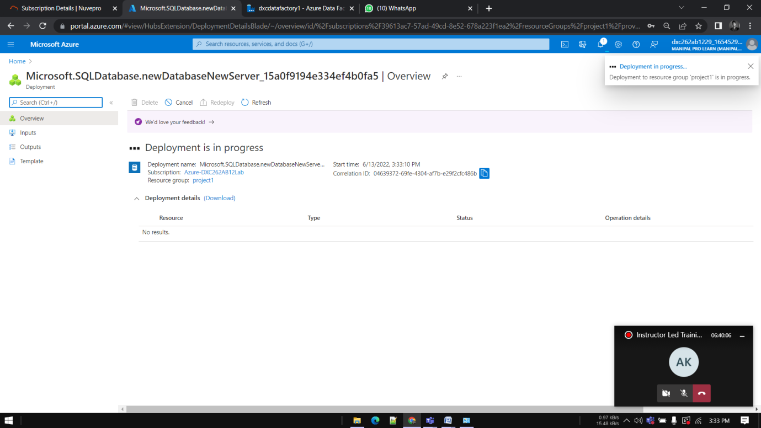

Go ahead to deploy the database

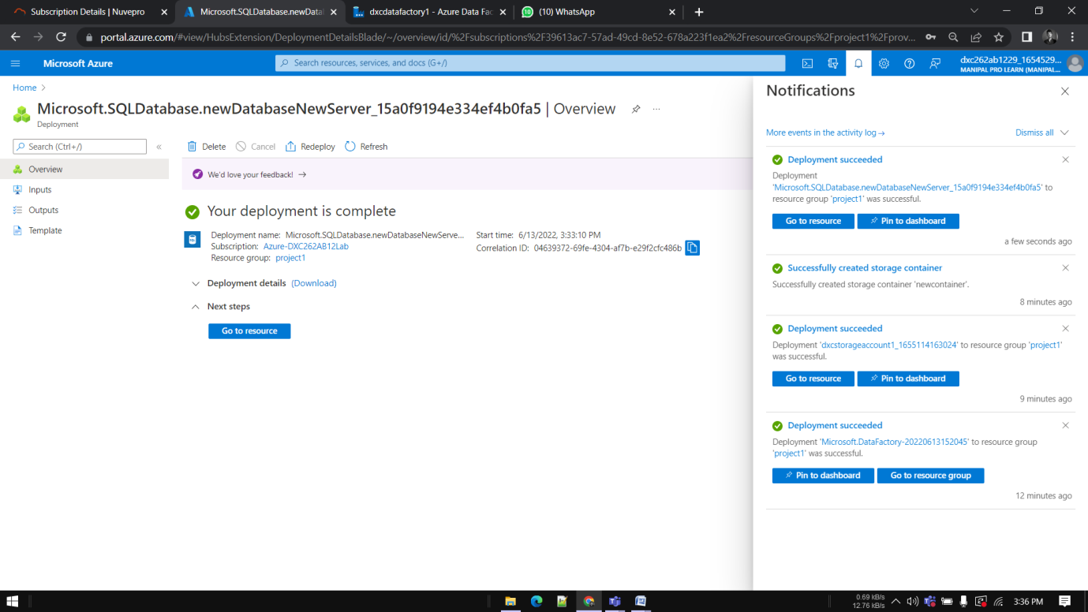

Go to Data factory that we created

Click on ingest

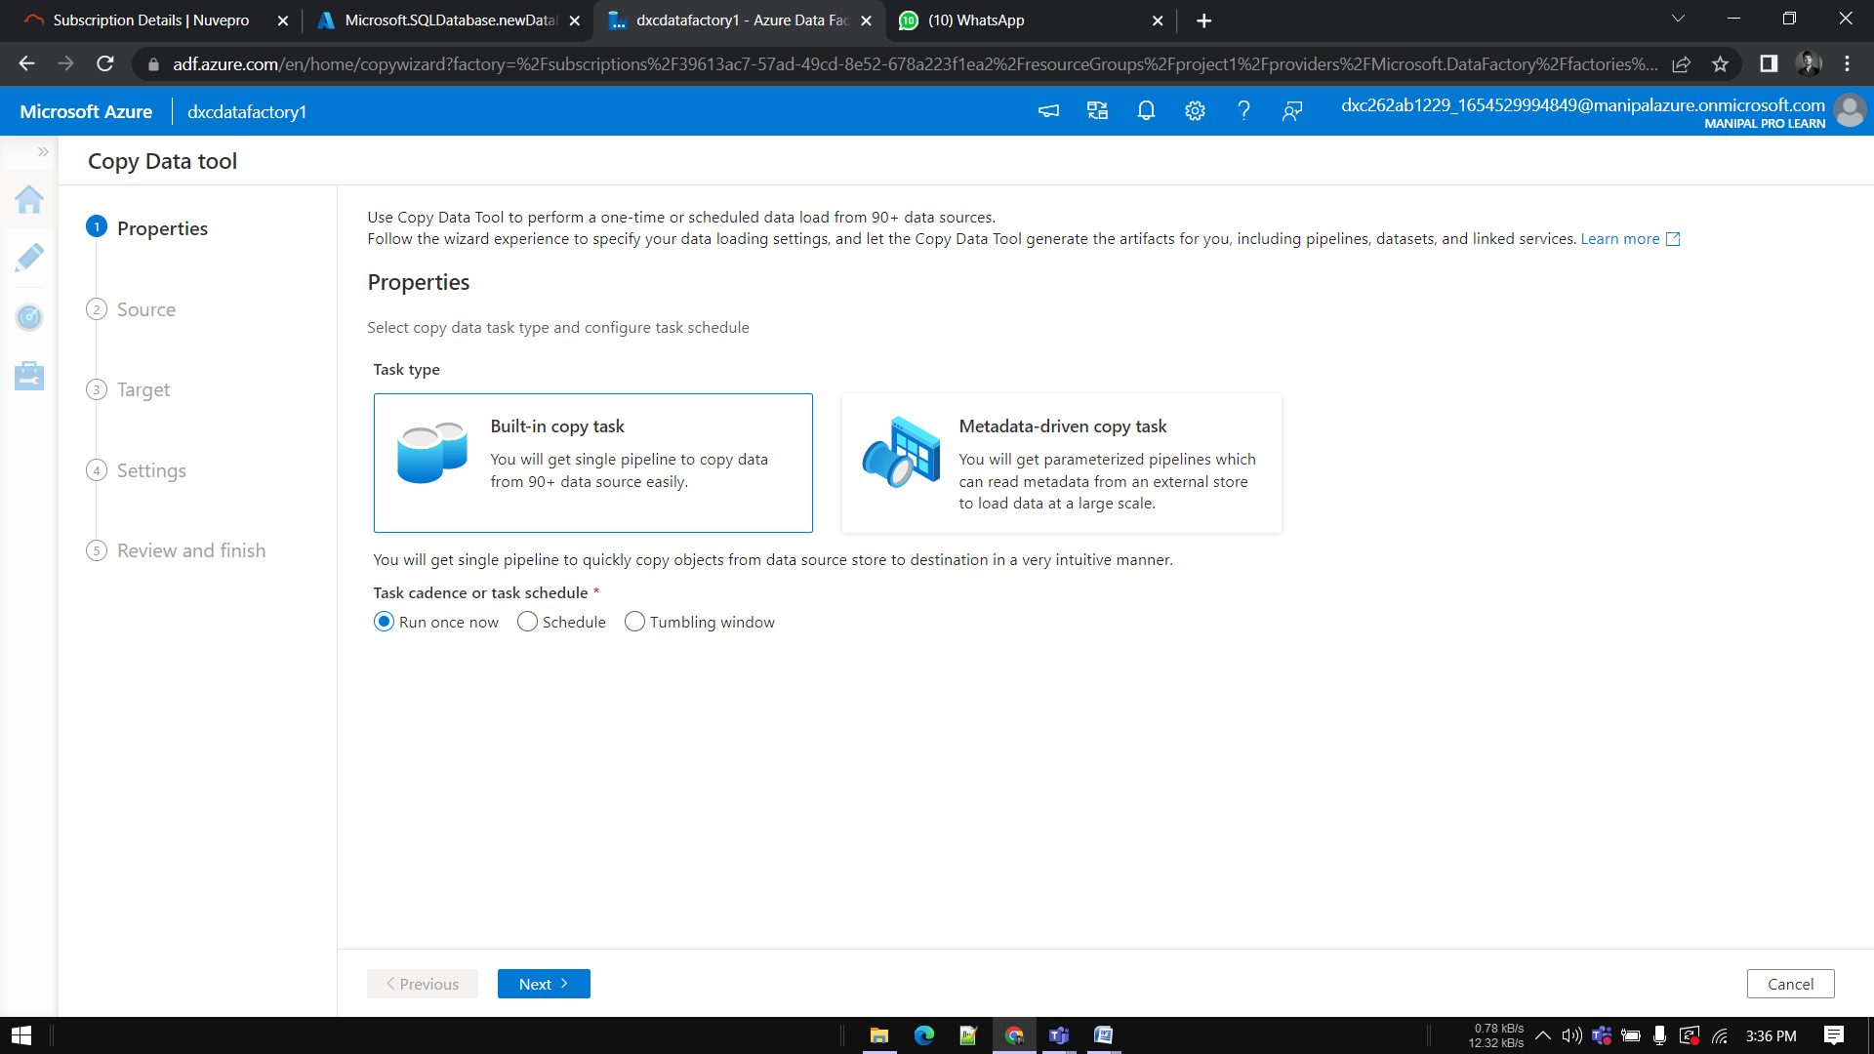

Enter the name of Azure blob storage linked file. Select the name of storage account name we created in this and click on Create.

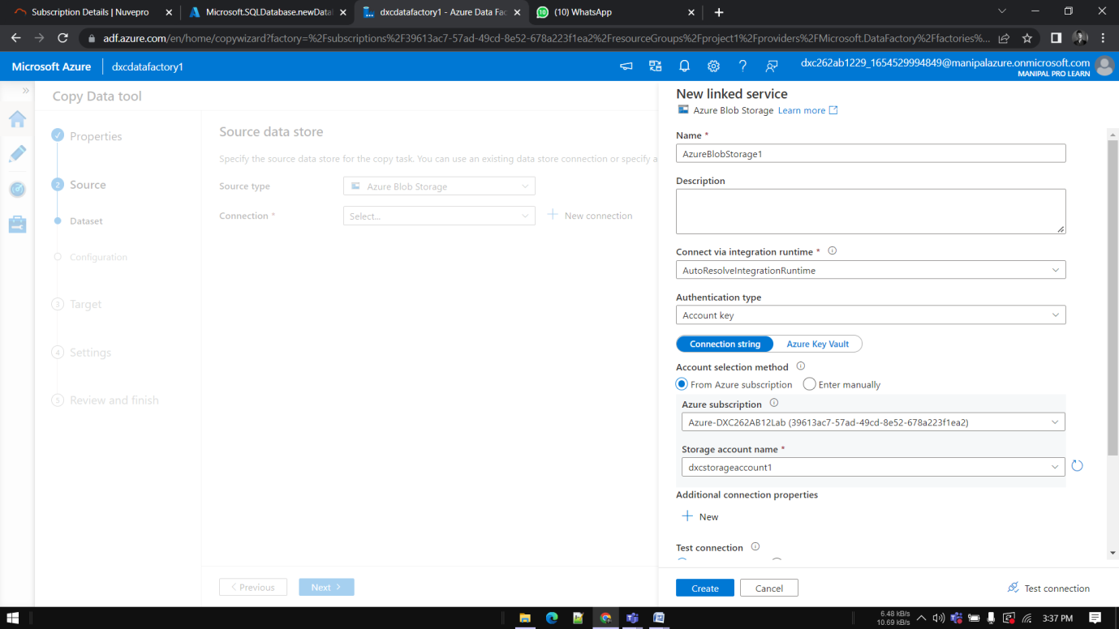

Give name and Click Next.

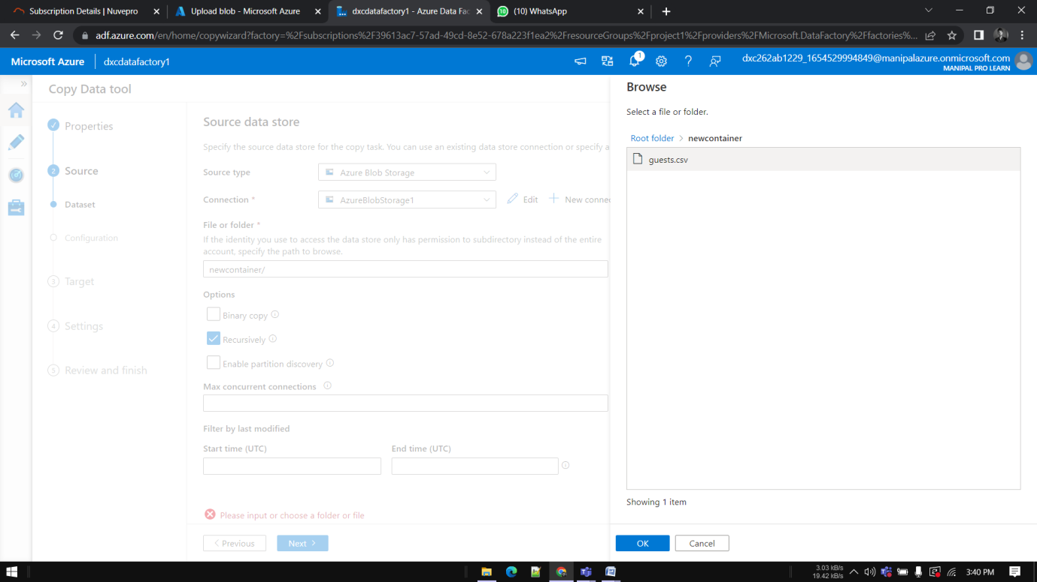

Choose the format of the data

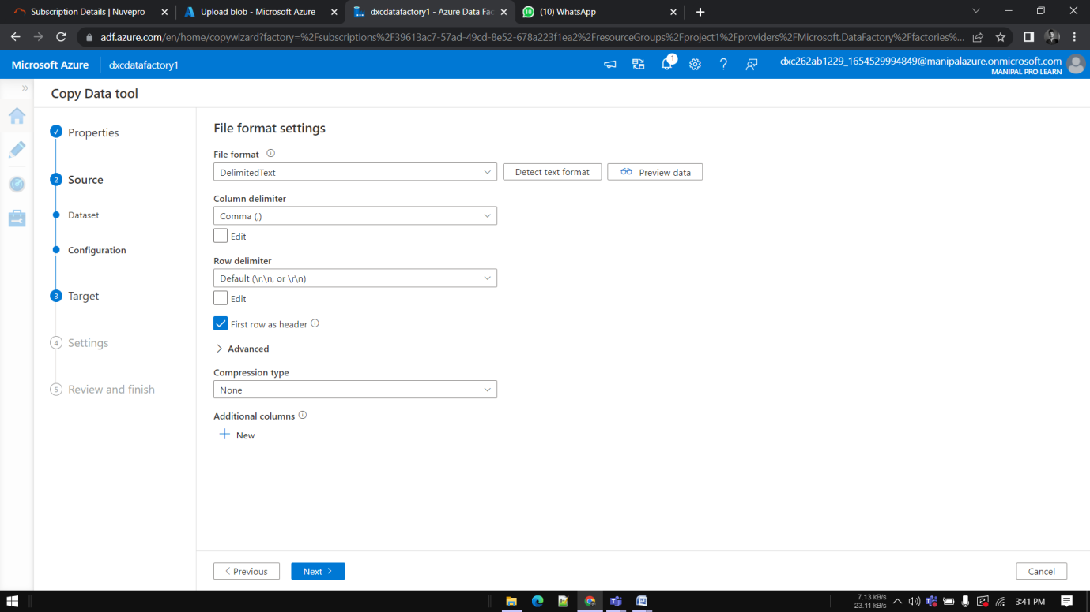

Connect the database with new connection.

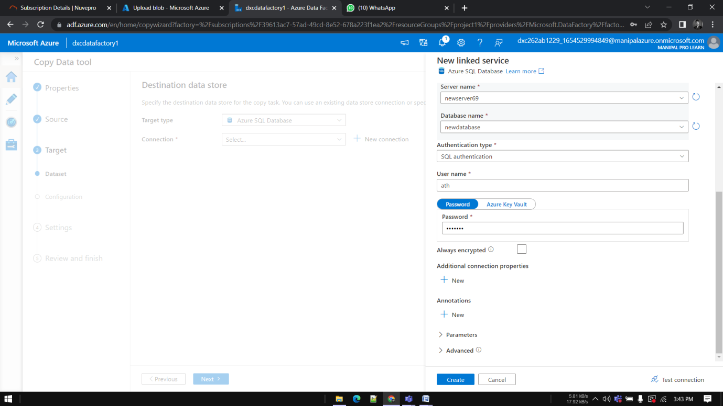

Give filename and Click Next.

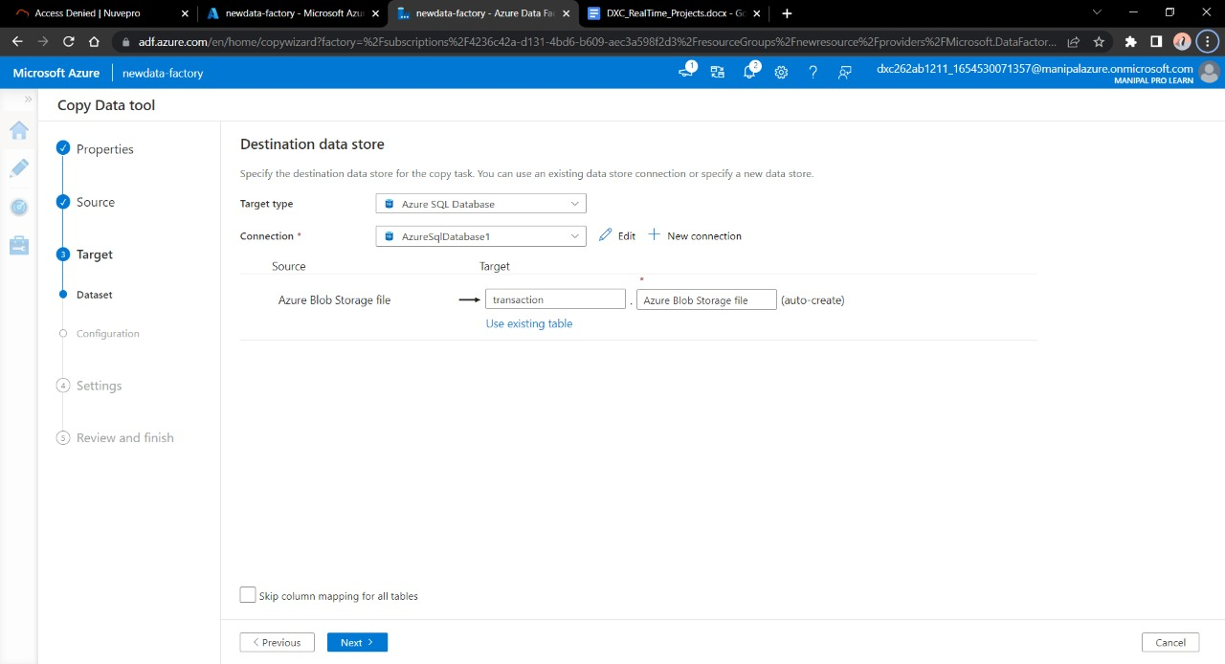

Validate the data , connection , details and move forwards with Next

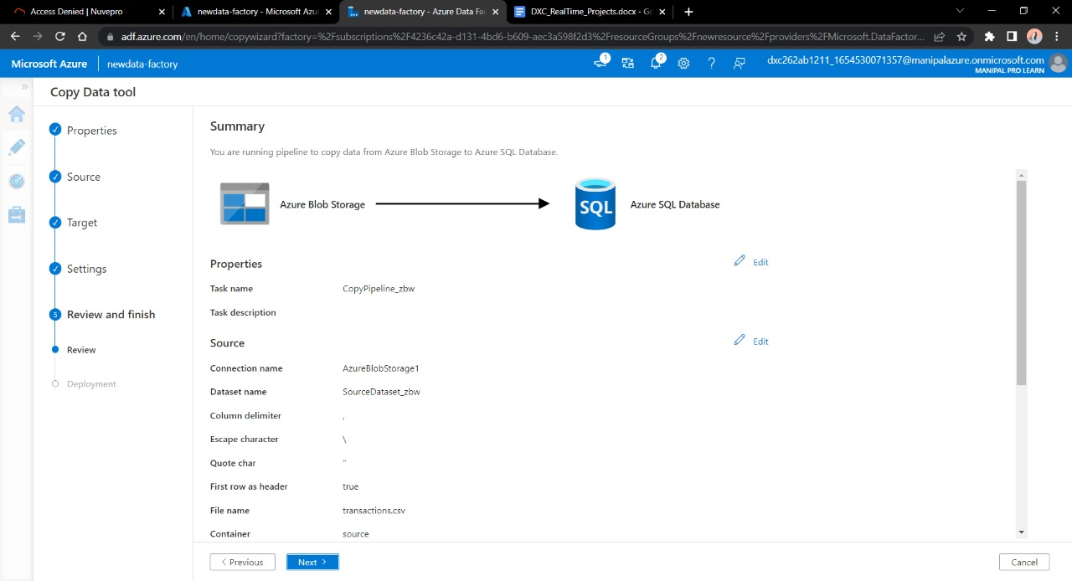

Trigger the pipeline 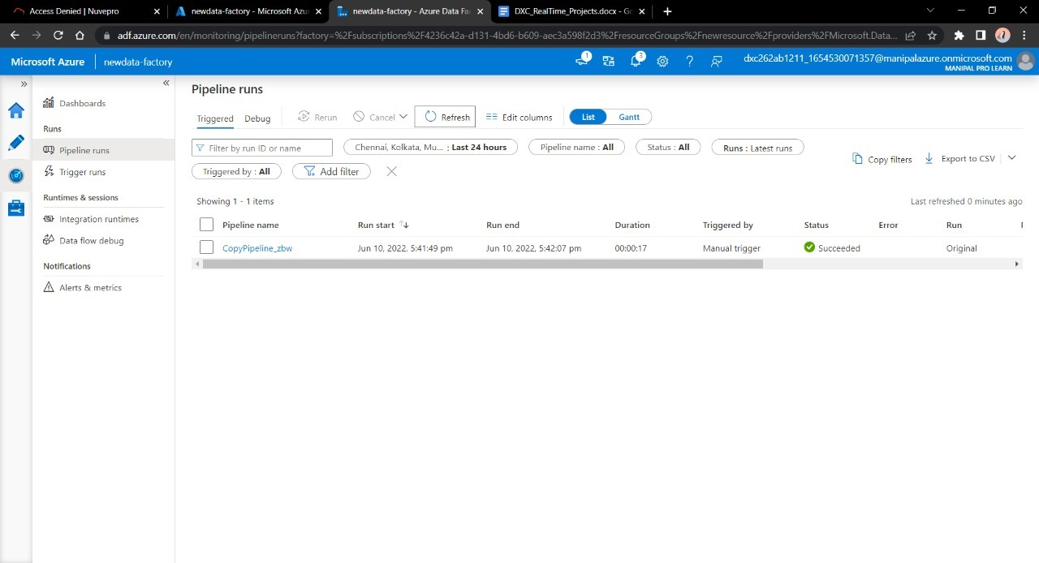

Go to SQL database in to check the data.

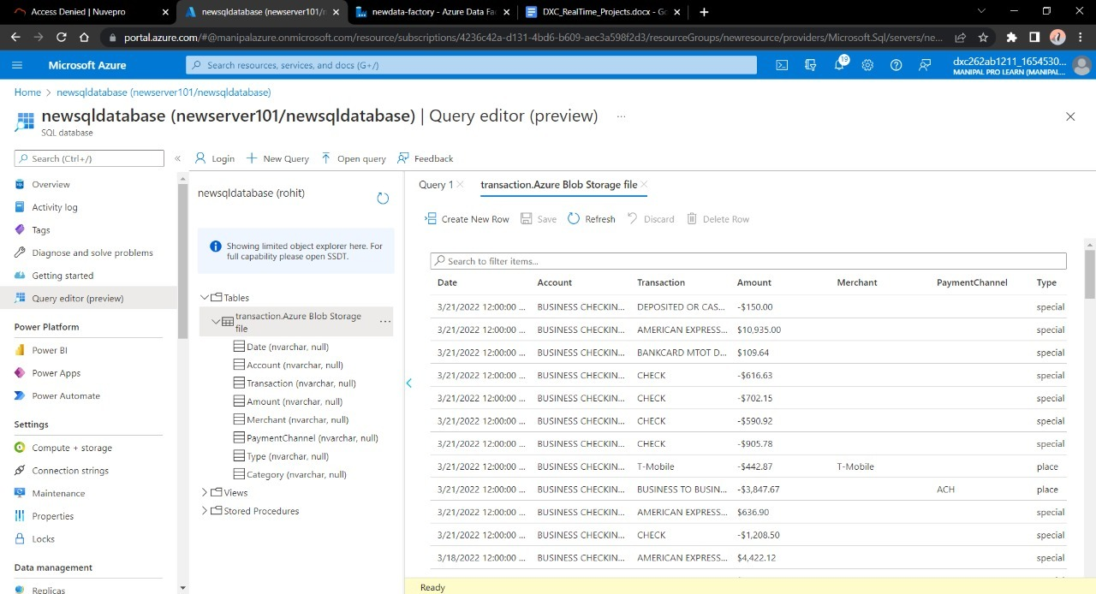

**Result: Created pipeline, copied blob data into sql using Azure Data Factory**

**Conclusion: Successfully created pipeline copied blob into sql using Azure Data Factory**

Name: Atharva Jadhav

Reg No: DXC262AB12035

**Project2 Name: AP Morgan Data Platform**

Date: 11th June 2022

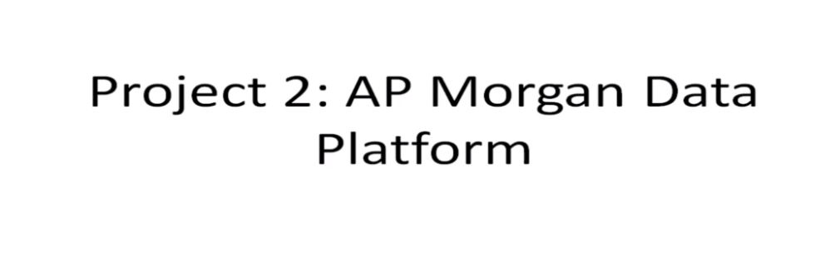

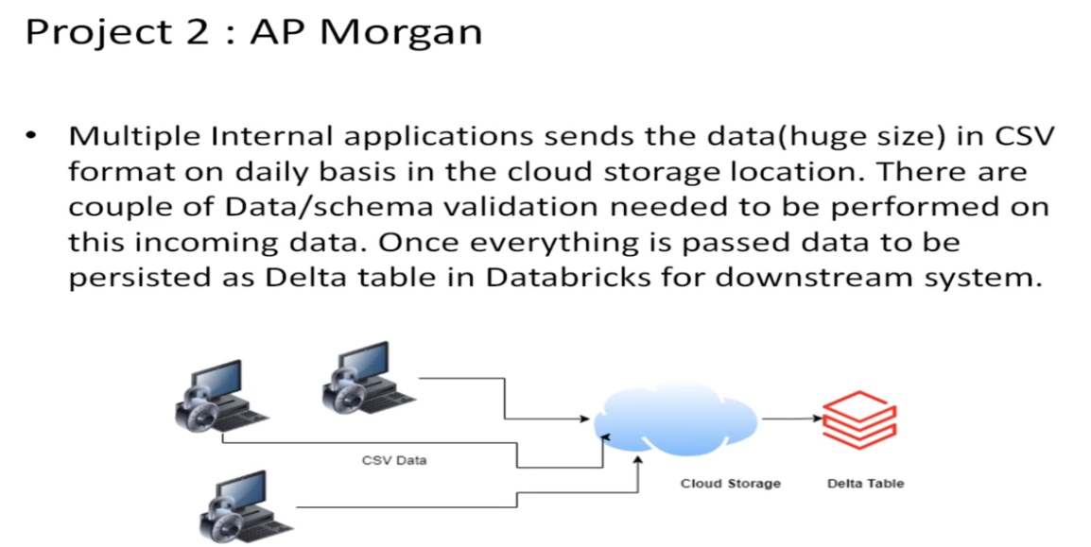

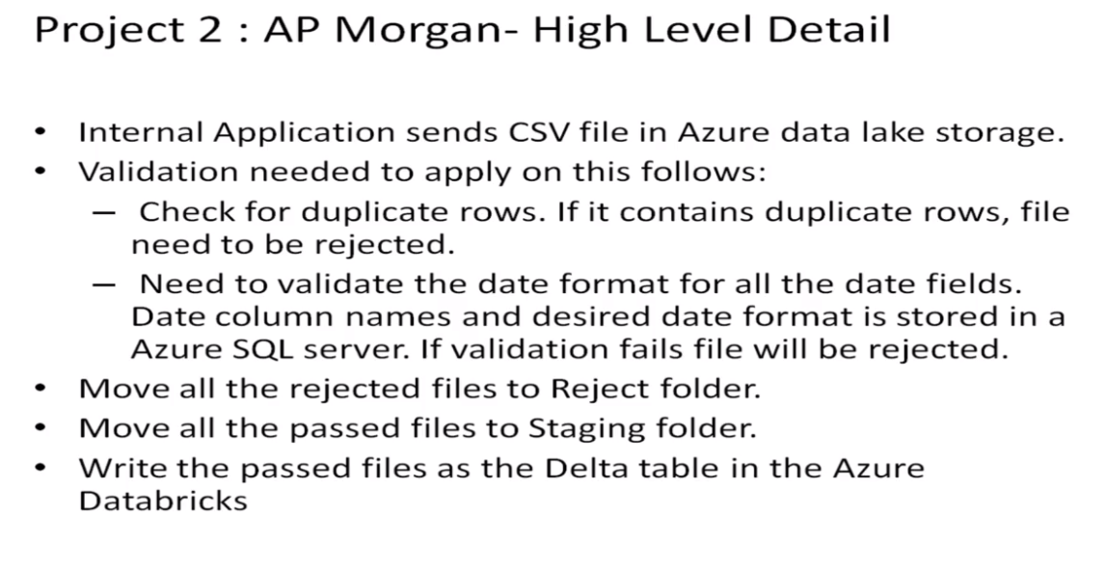

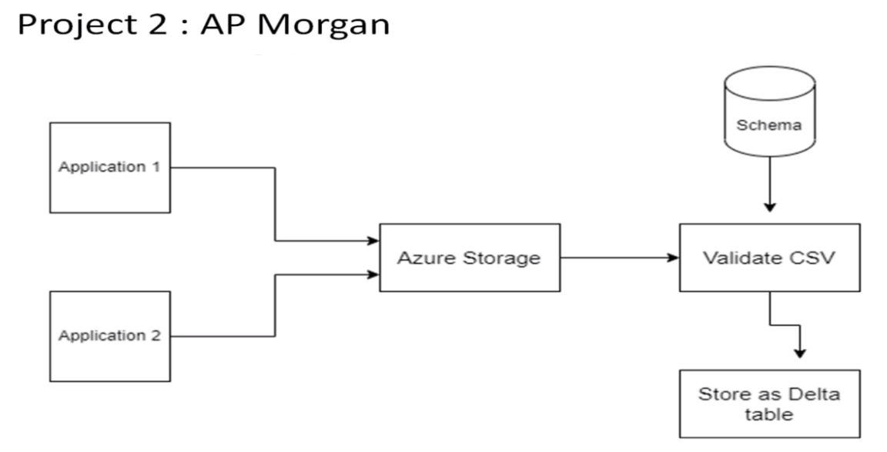

Practical Lab: Create a **Databricks**

Practical Lab: Create **Cluster in Azure Databricks**

Practical Lab: **Add notebook in Databricks** and Implement the Business Logic

Practical Lab: **Azure Data Factory** For AP Morgan

Practical Lab: **Create Azure Databricks** Linked Service in ADF

1.Open Azure dashboard and click on Azure Databricks

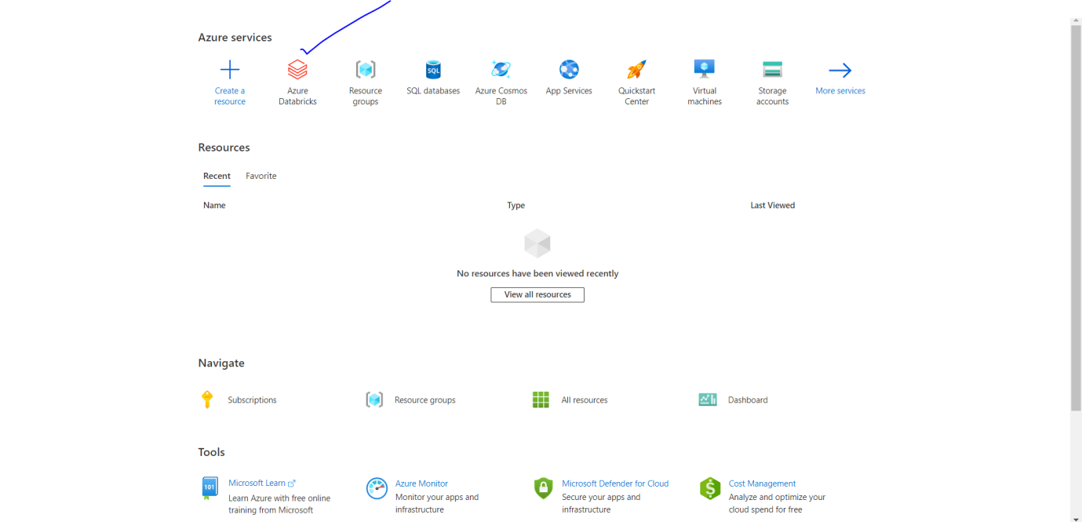

2.Click on CREATE

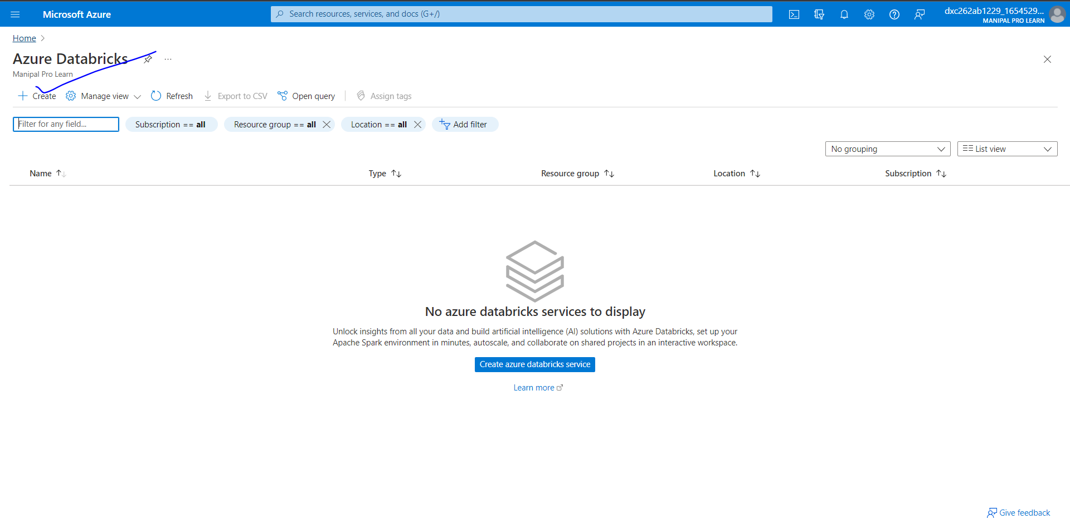

3.Select or create resource and give resource name

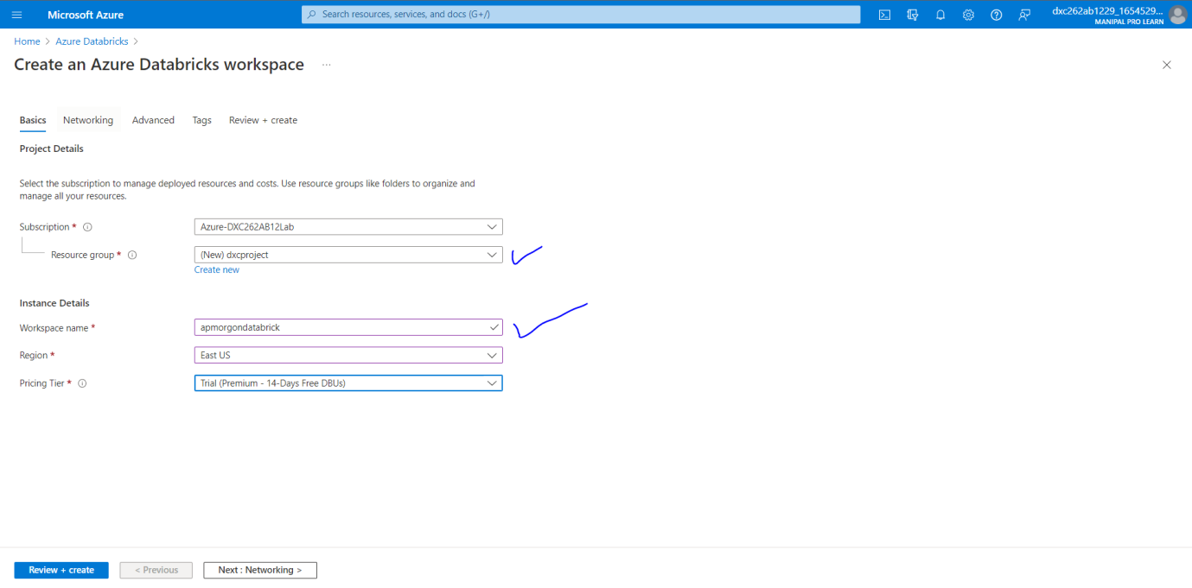

4. Click on review and create

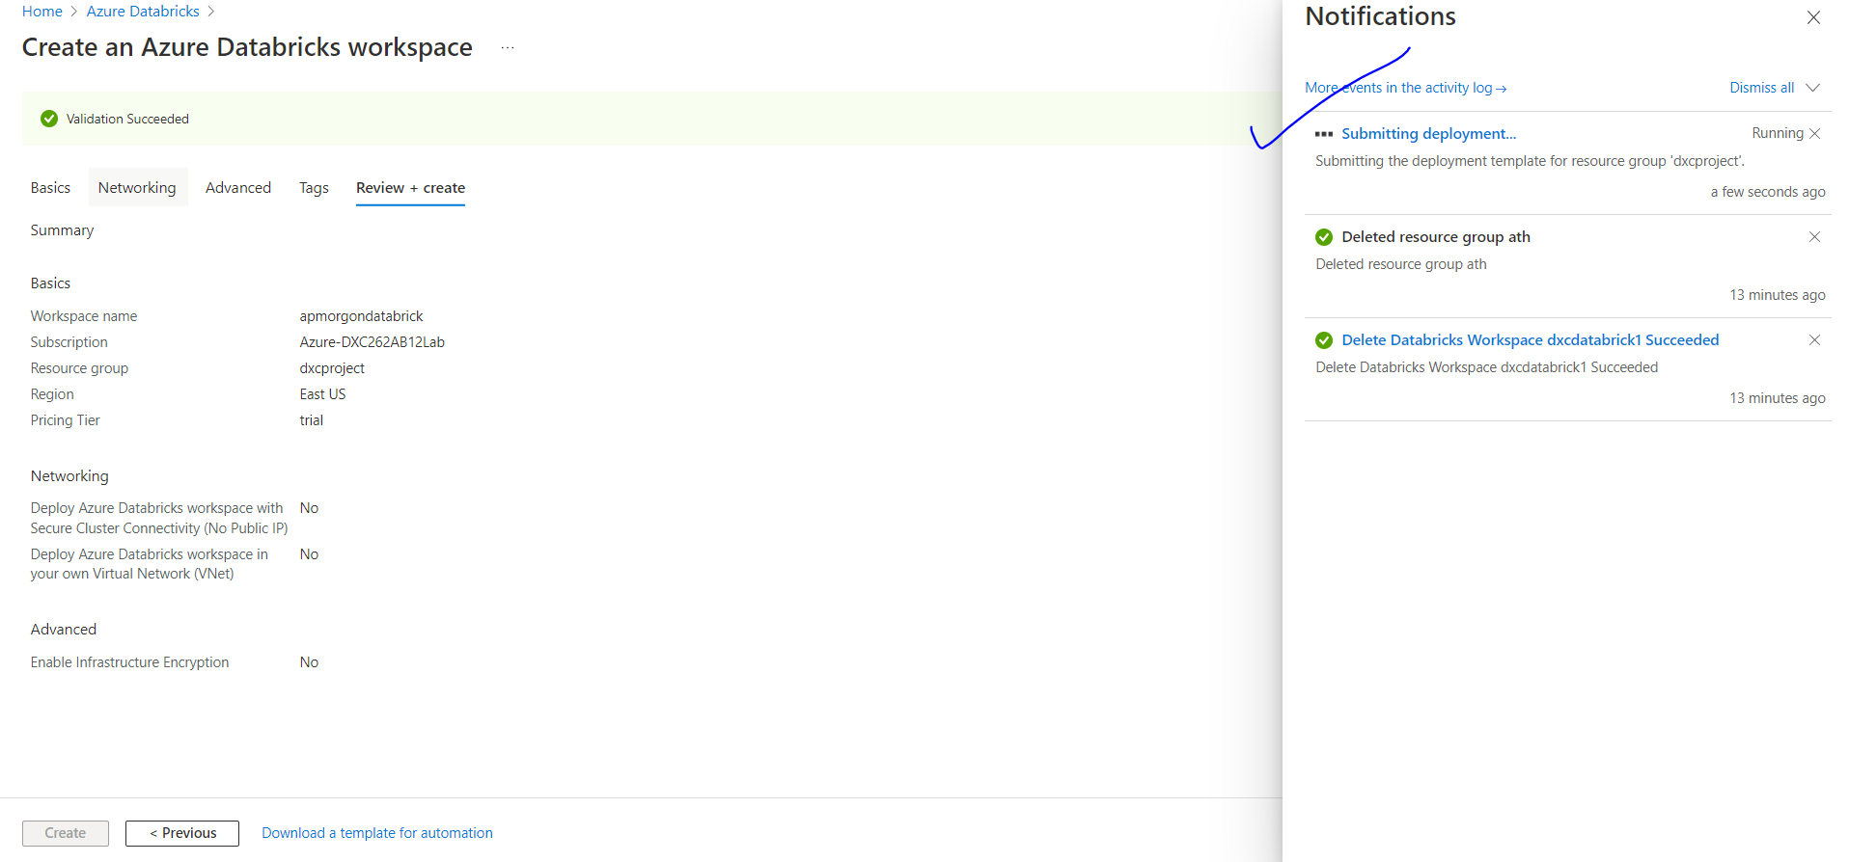

give permission for Cluster connectivity

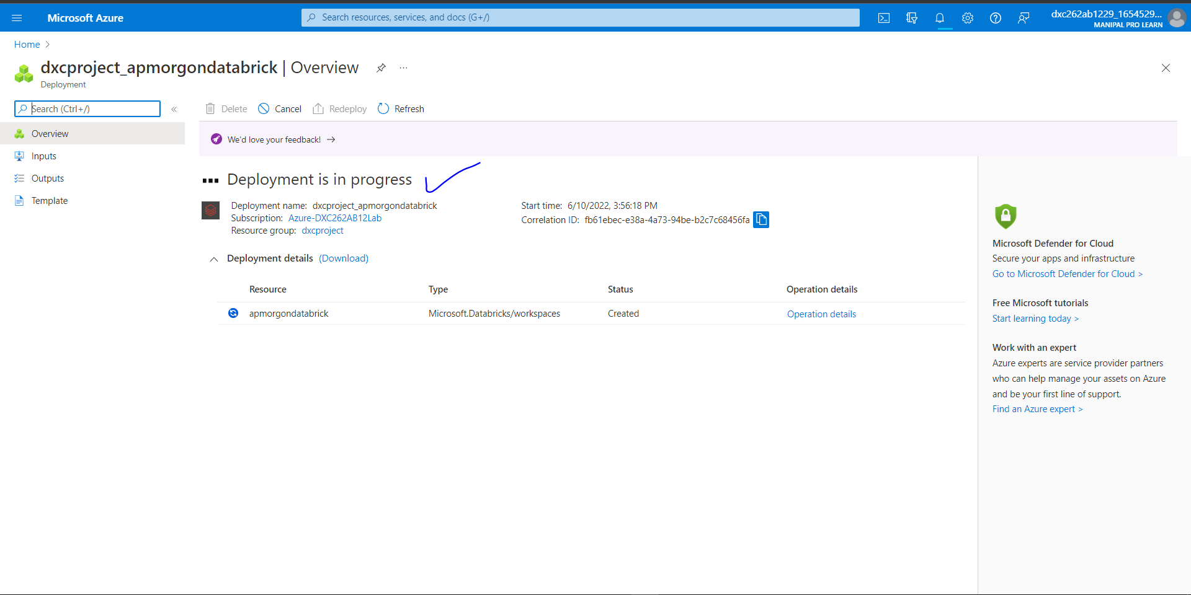

6.Successfully deployed azure data bricks

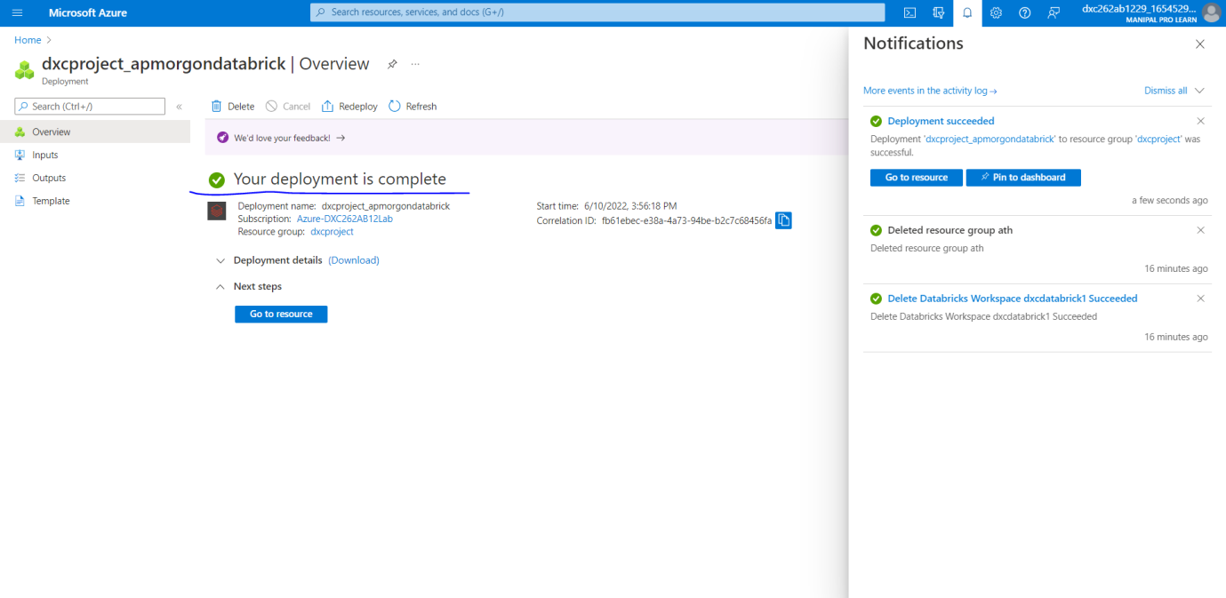

After the deployment is done Navigate towards “Go to Resource”

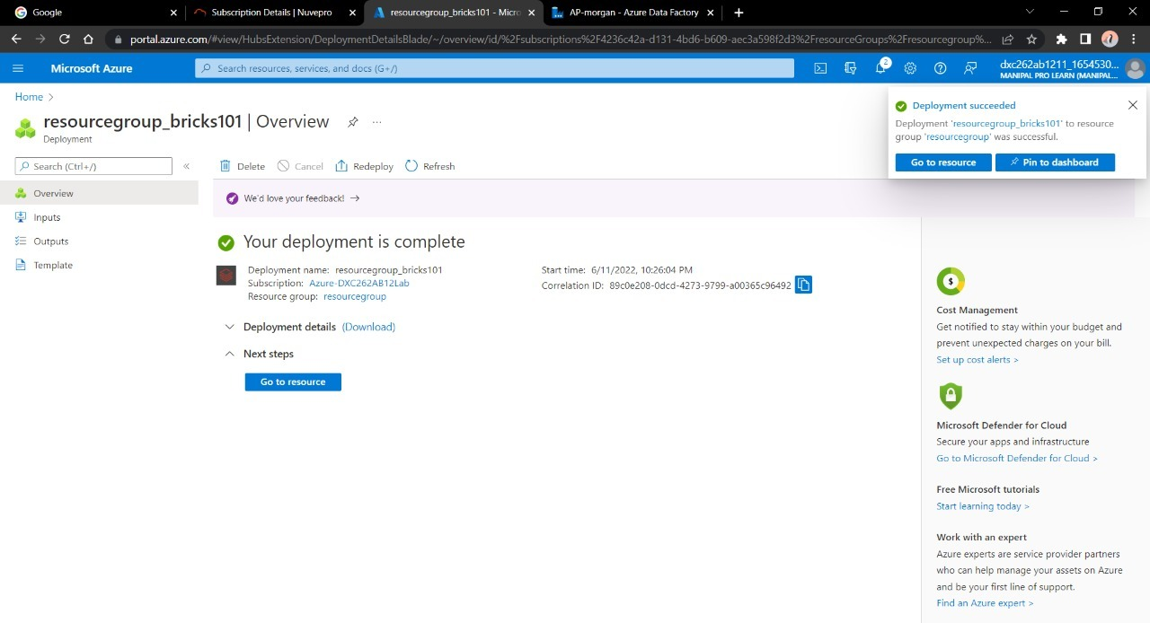

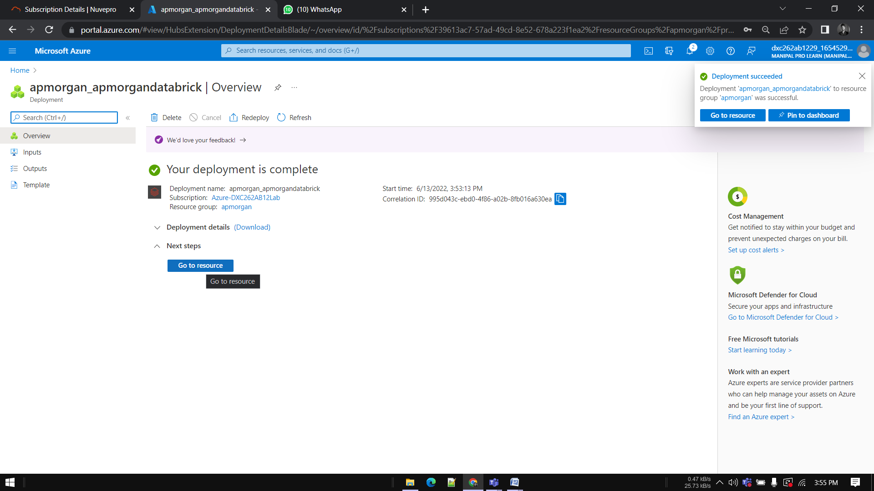

Launch the Workspace

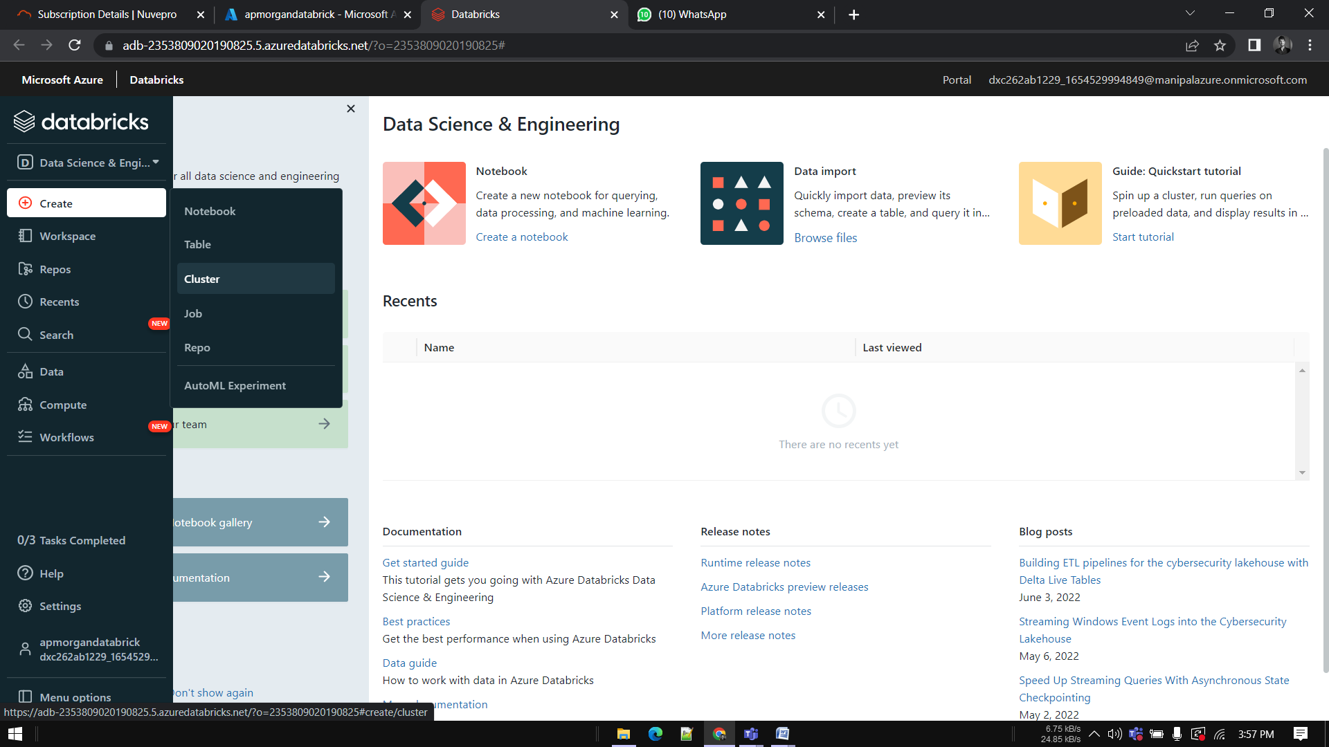

Create a new cluster

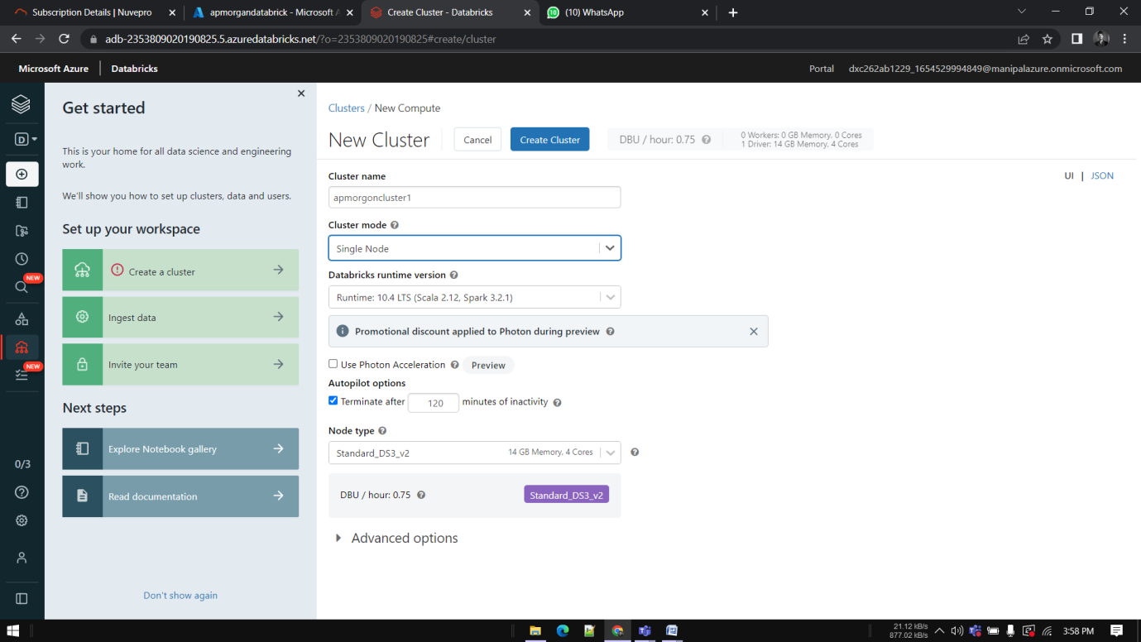

Give the necessary credentials for the cluster and click on create

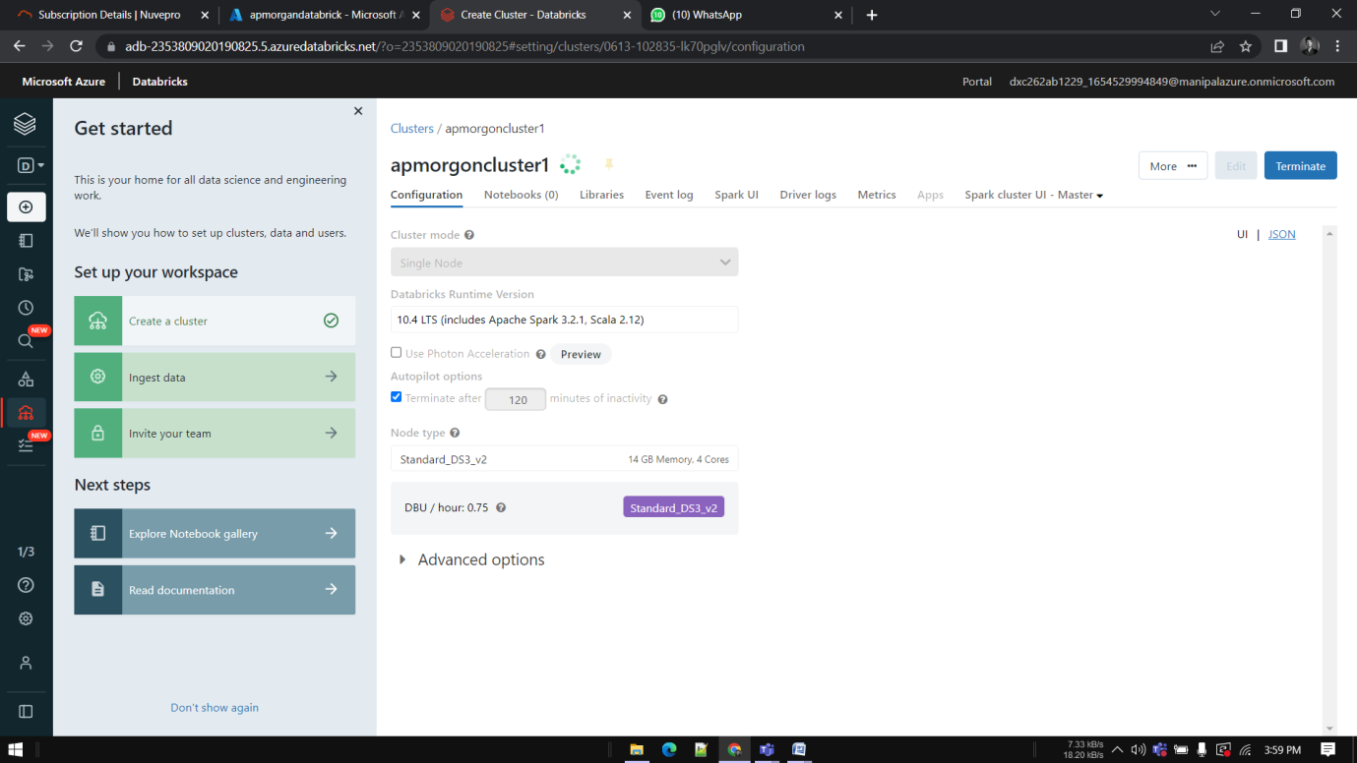

Create notebook

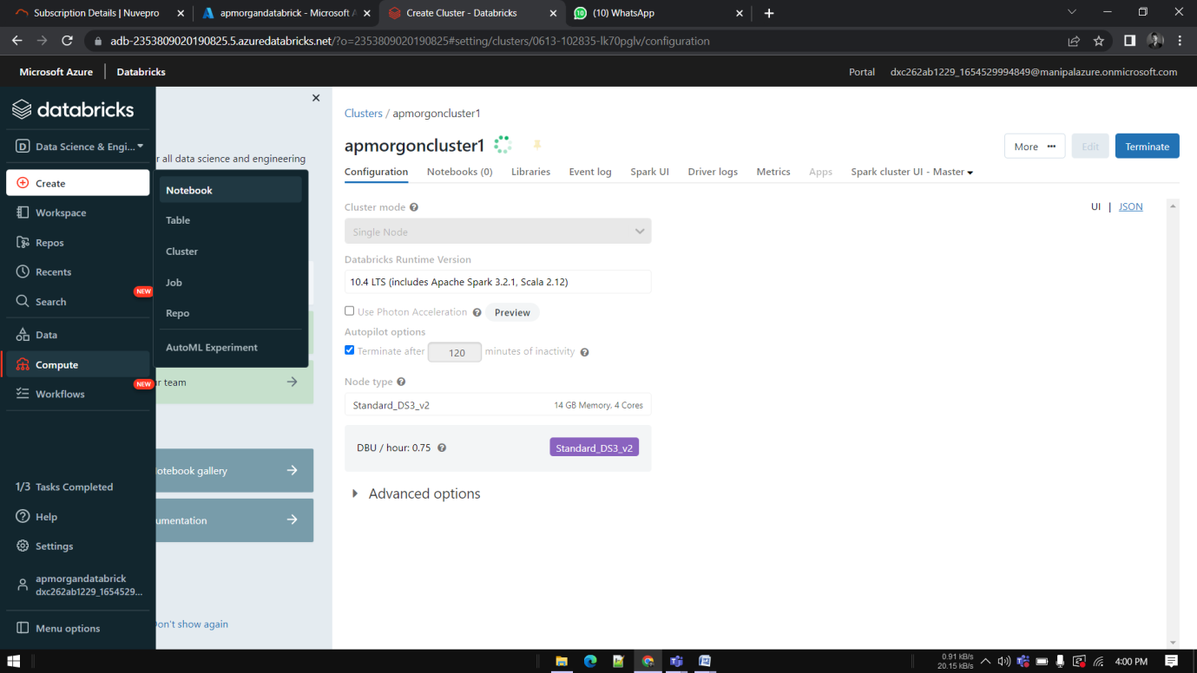

Give some operation or Do the logic building in the notebook

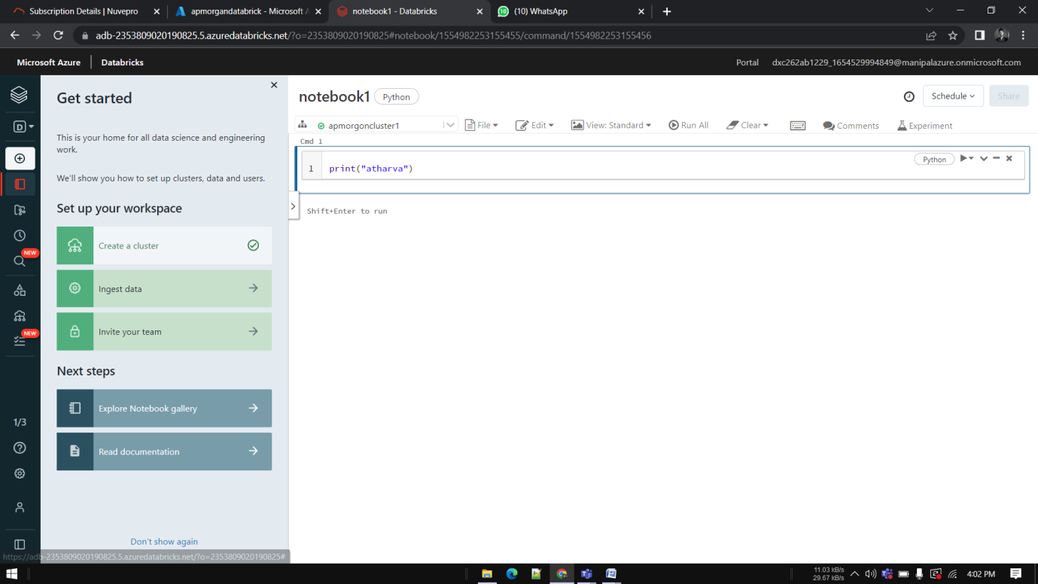

Go to azure page and create Data Factory

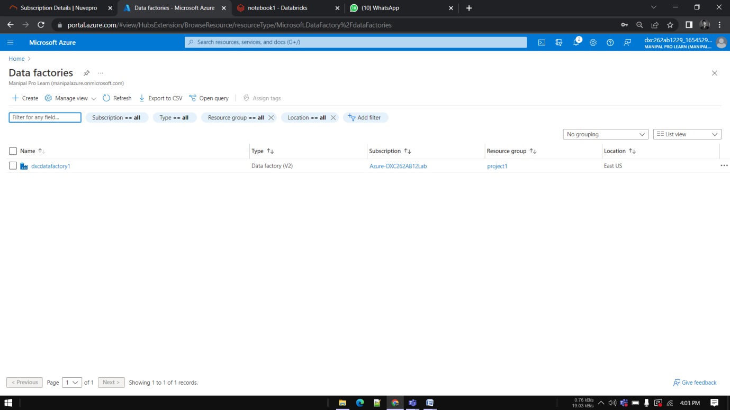

Enter the details for the factory account and deploy

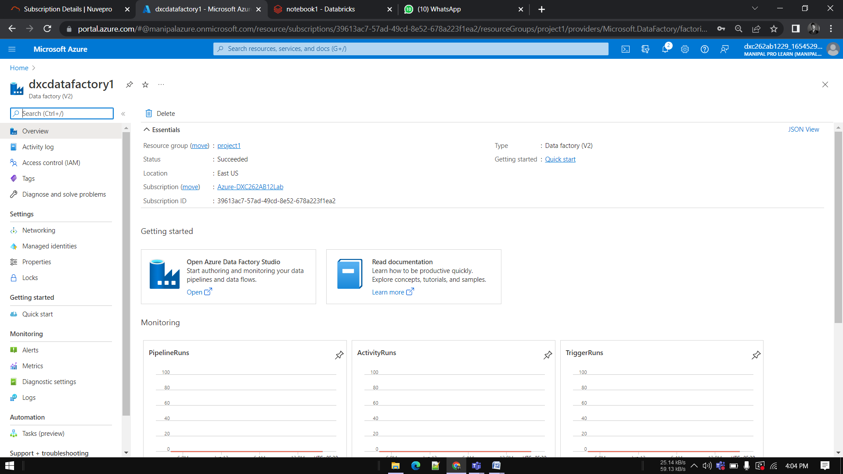

Now open the Data Factory studio

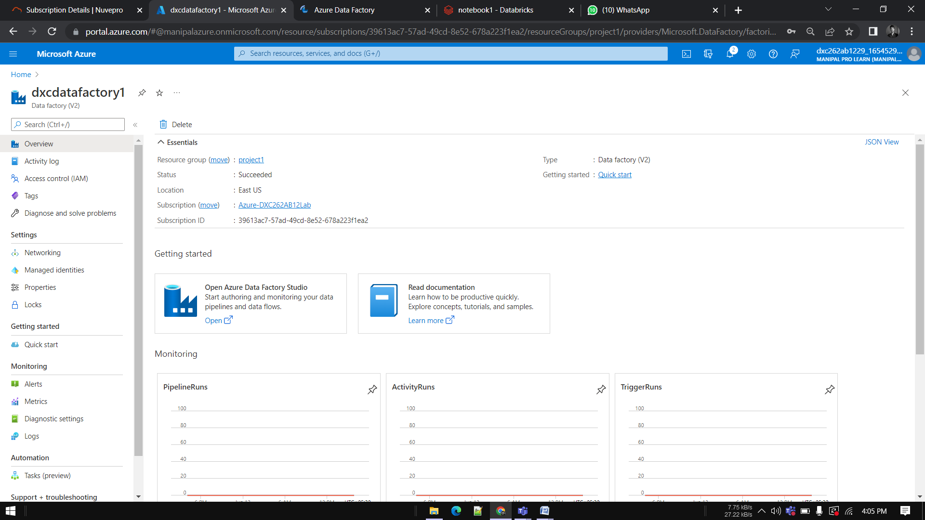

We need to create a pipeline 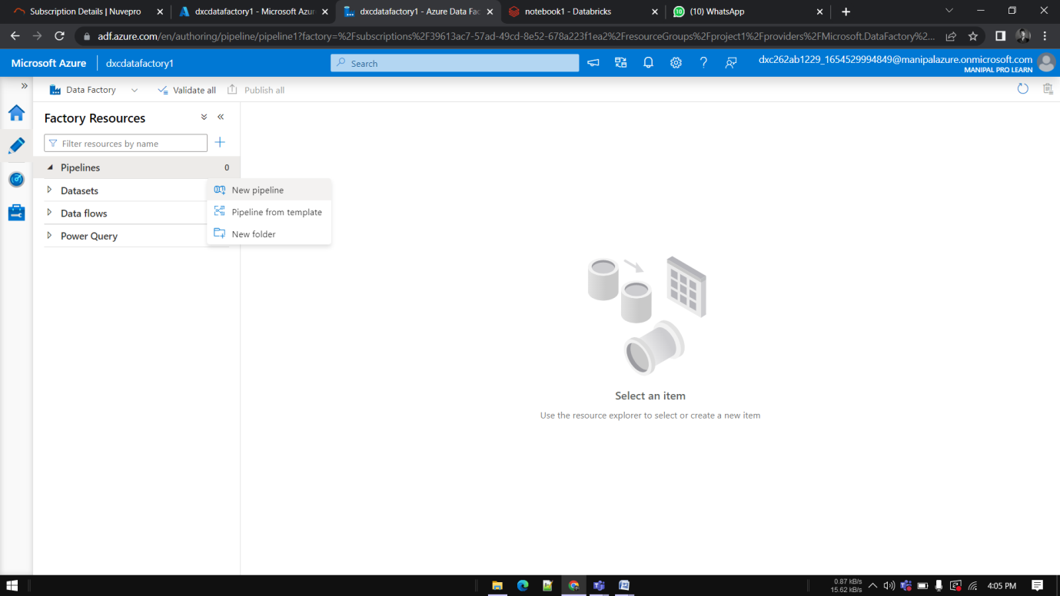

Create a new Pipeline and drop the notebook tab from Azure Databricks dropdown into the pipeline workspace.

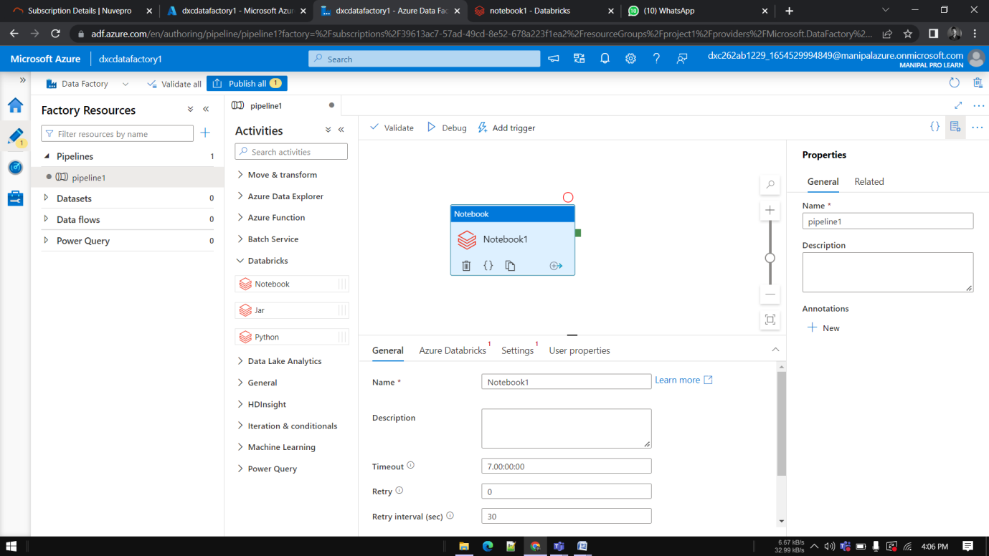

Create a new Linked service 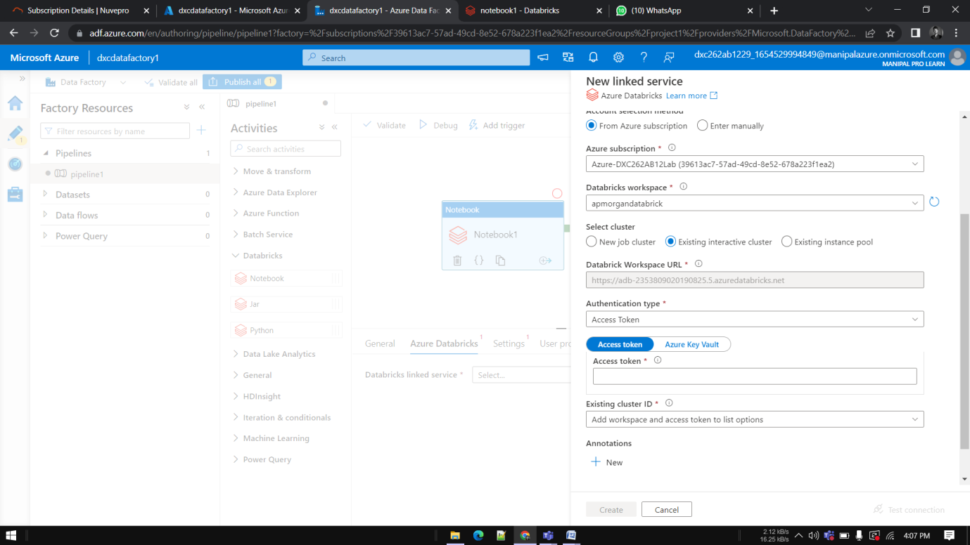

Go to Data bricks and go to Users in settings

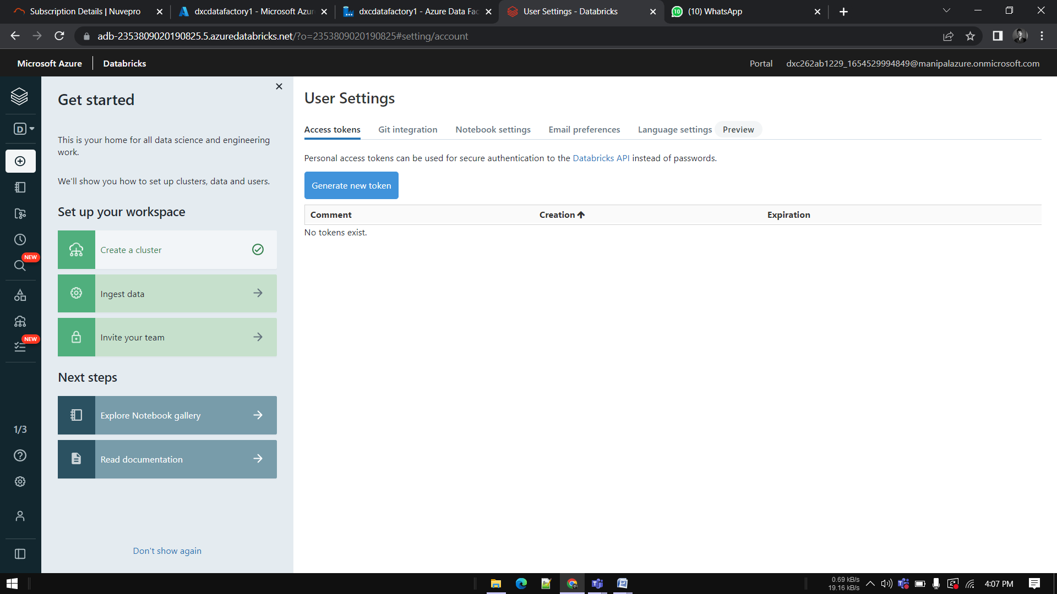

Click on Generate token

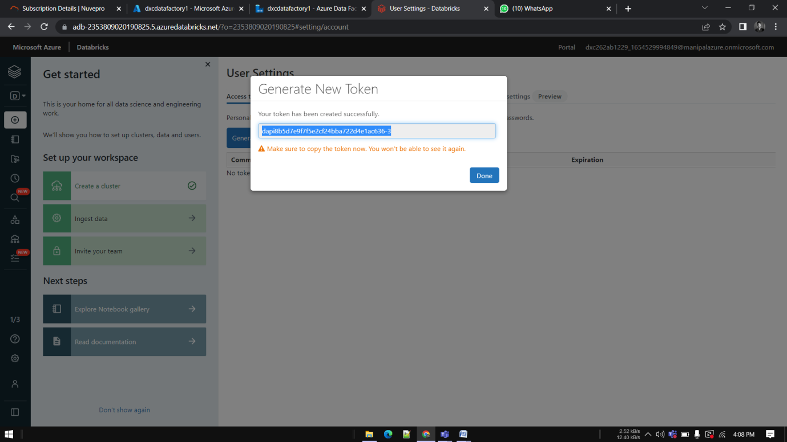

paste it in the azure factory data connection form

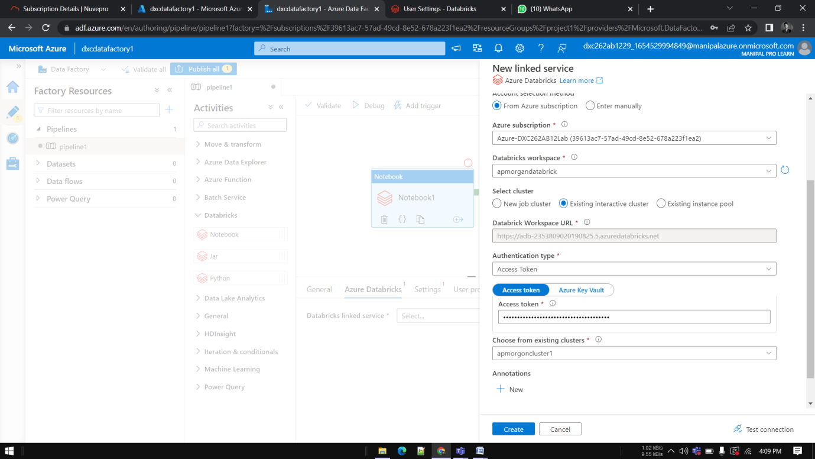

Choose the right cluster and click on create

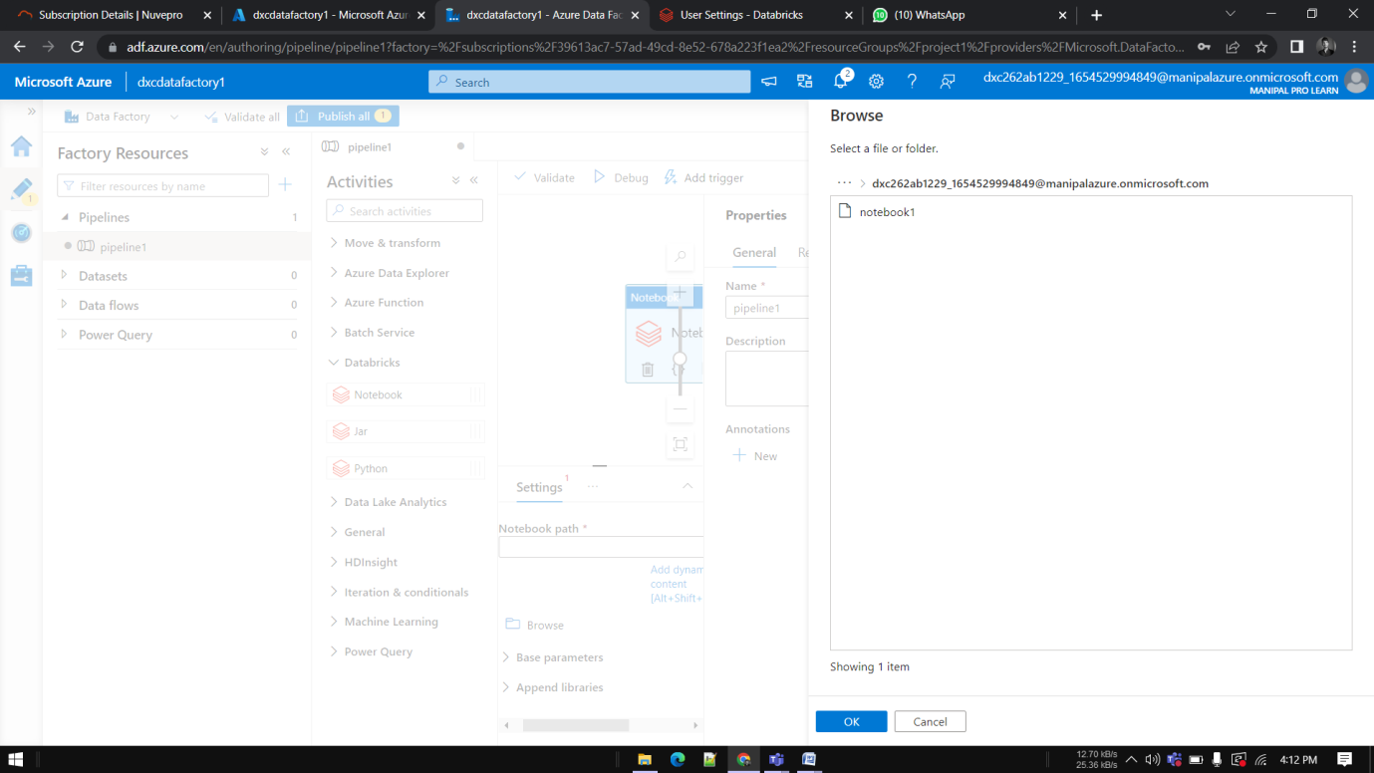

Publish the pipeline, After publication click on Trigger now

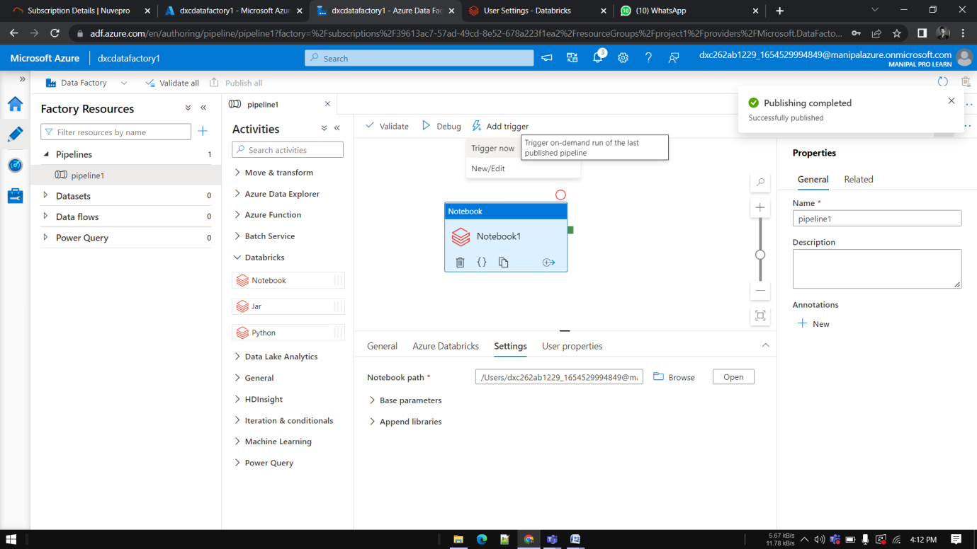

Go to Monitor window in order to check it’s execution

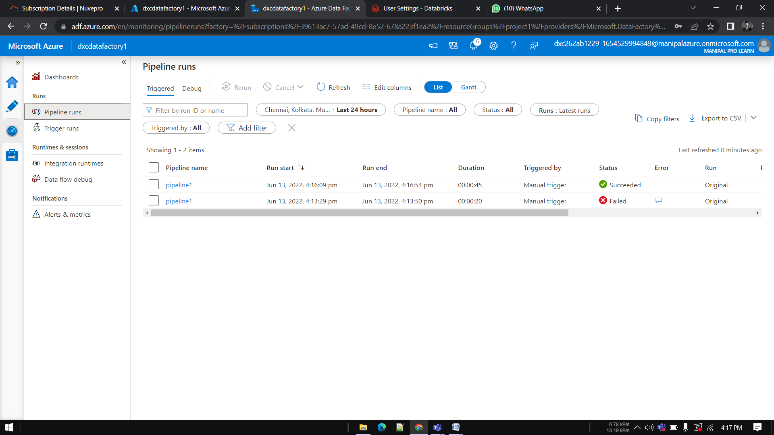

**Result:** Successfully done linking and triggering DataBricks notebook using Data Factory.

**Conclusion:** Azure Data Factory linked with Data bricks